**SOFTWARE ENGINEERING DEPARTMENT**

** Fall 2016**

**CMPE 273 – Enterprise Distributed Systems – Team Project**

**Airbnb**

**Team Number 4**

**GitHub : https://github.com/Jayam-Malviya/--AirBnb--**

**Password:godspeedgh1**

|  |  |
| --- | --- |
| **Team Member** | **SJSU ID** |
| Aniruddha Pratap Singh | 011432317 |
| Gaurang Mahatre | 011432200 |
| Jayam Malviya | 011435567 |
| Kunal Ahuja | 010731227 |
| Mayank Sharma | 011435320 |
| Prateek Sharma | 011475620 |

**Member Contribution towards the Group Project**

* **Aniruddha Pratap Singh:**

Design and development of Host Module – Back End

Pagination

* **Gaurang Mhatre :**

Design and development of Admin module – Front End

Redis Caching

* **Jayam Malviya:**

Admin Analytics

Jmeter Testing

* **Kunal Ahuja :**

Design and development of trip module- backend

Google Map API Integration

* **Mayank Tanwar:**

Design and development of Host Module – Front End

User Authentication

* **Prateek Sharma :**

Design and development of trip bidding

Trip Module-front End.

* **Introduction**

Goal

The application is the replica of Airbnb. In this project we are building an application where the user can either host other people by renting his property for a short period of time or the user can be a guest if he books property hosted by other user. The user can make payment, view the listings on map and provide reviews for other properties and people.

Purpose of System

We learn web development using MEAN stack and RabbitMQ a message broker which uses AMQP protocol for scalability. We have also used Redis for cache management.

* **System Design**
* Front End/GUI Technologies
* HTML
* CSS/Bootstrap
* JavaScript
* Angular JavaScript
* Back End/ Server Technologies
* Node Java Script
* Rabbit MQ (Message Broker)
* Databases
* MongoDB
* MySQL
* Redis (for caching)
* Framework
* Express
* **Object Management Policy**
* Requirement Analysis:

Planning and requirement analysis phase is the first phase of our application, as per the requirements the application is divided into three layers:

1. Presentation Layer: The presentation layer consists of the graphical user interface of our application. The user interacts with the user interface to send requests to the server.
2. Business Layer: The business layer consists of the implementation of business logic. In this layer we translate the functional requirements into working code, that is, this layer is responsible for processing of the requests received from the user and to return valid response. The modules have been implemented using the message broker Rabbit MQ which implements the Advance Messaging and Queuing Protocol. The various modules are also integrated in this layer.
3. Data Layer: The data layer comprises of the database to store the data for various modules. In this layer we define the relationship between different tables. We have used both MongoDB and MySQL to store the data.

* Modules:

We have implemented various modules as per the requirements namely, Host, Trips, Billing and Admin. The host model stores the data about the host and the property he has listed. The trips module stores the data about the trip of the user. The billing module stores the bills for various trips and admin model has the data for all the users, their trips, lists and bills. Each of these module has its own characteristics and schema.

* Implementation:

We have implemented the user interface and various functionalities for each of the modules mentioned above. We have implemented key features like address validator to validate the address of the property entered by the user, maps using google map API which the properties in a particular area on google map. We have used Rabbit MQ as message broker between the client and server which makes the application reliable and scalable. We have also used Redis for caching sql data.

* Testing:

We have tested our application using mocha and jmeter. The various graphs shown below discusses the result of jmeter testing. We also tested application using Mocha to check if the functionalities are as expected.

* **How we handled “Heavy Weight” resources.**

The heavy weight resources in our application are the profiles images and profile videos of the user, the images of the property that the user saved while listing his property for rent and the images uploaded by the user while reviewing a property. We have followed industry best practices and used Amazon S3 to store these images, retrieving the images from cloud is less expensive than fetching the images from database.

* **The policy you used to decide when to write data into the database**

We are storing the data into the database optimally. For Example, while posting a property on rent the user has to enter the information about the property in multiple pages, we are not storing the data into the database at each page rather we store the data in the database only at the last step, this way if the user wishes to cancel the booking in between we don’t have to rollback all the data and also we don’t have to store the data into the database at each step. Similarly, in trips we are fetching the listings of a particular city only once from the database and then we store this data in local storage, we use this locally saved data in the next booking screens and save the data about the booking at the last step.

**Walkthrough:**

1)HomePage:

This page provides user with options like SignUp and SignIn and Search Places.

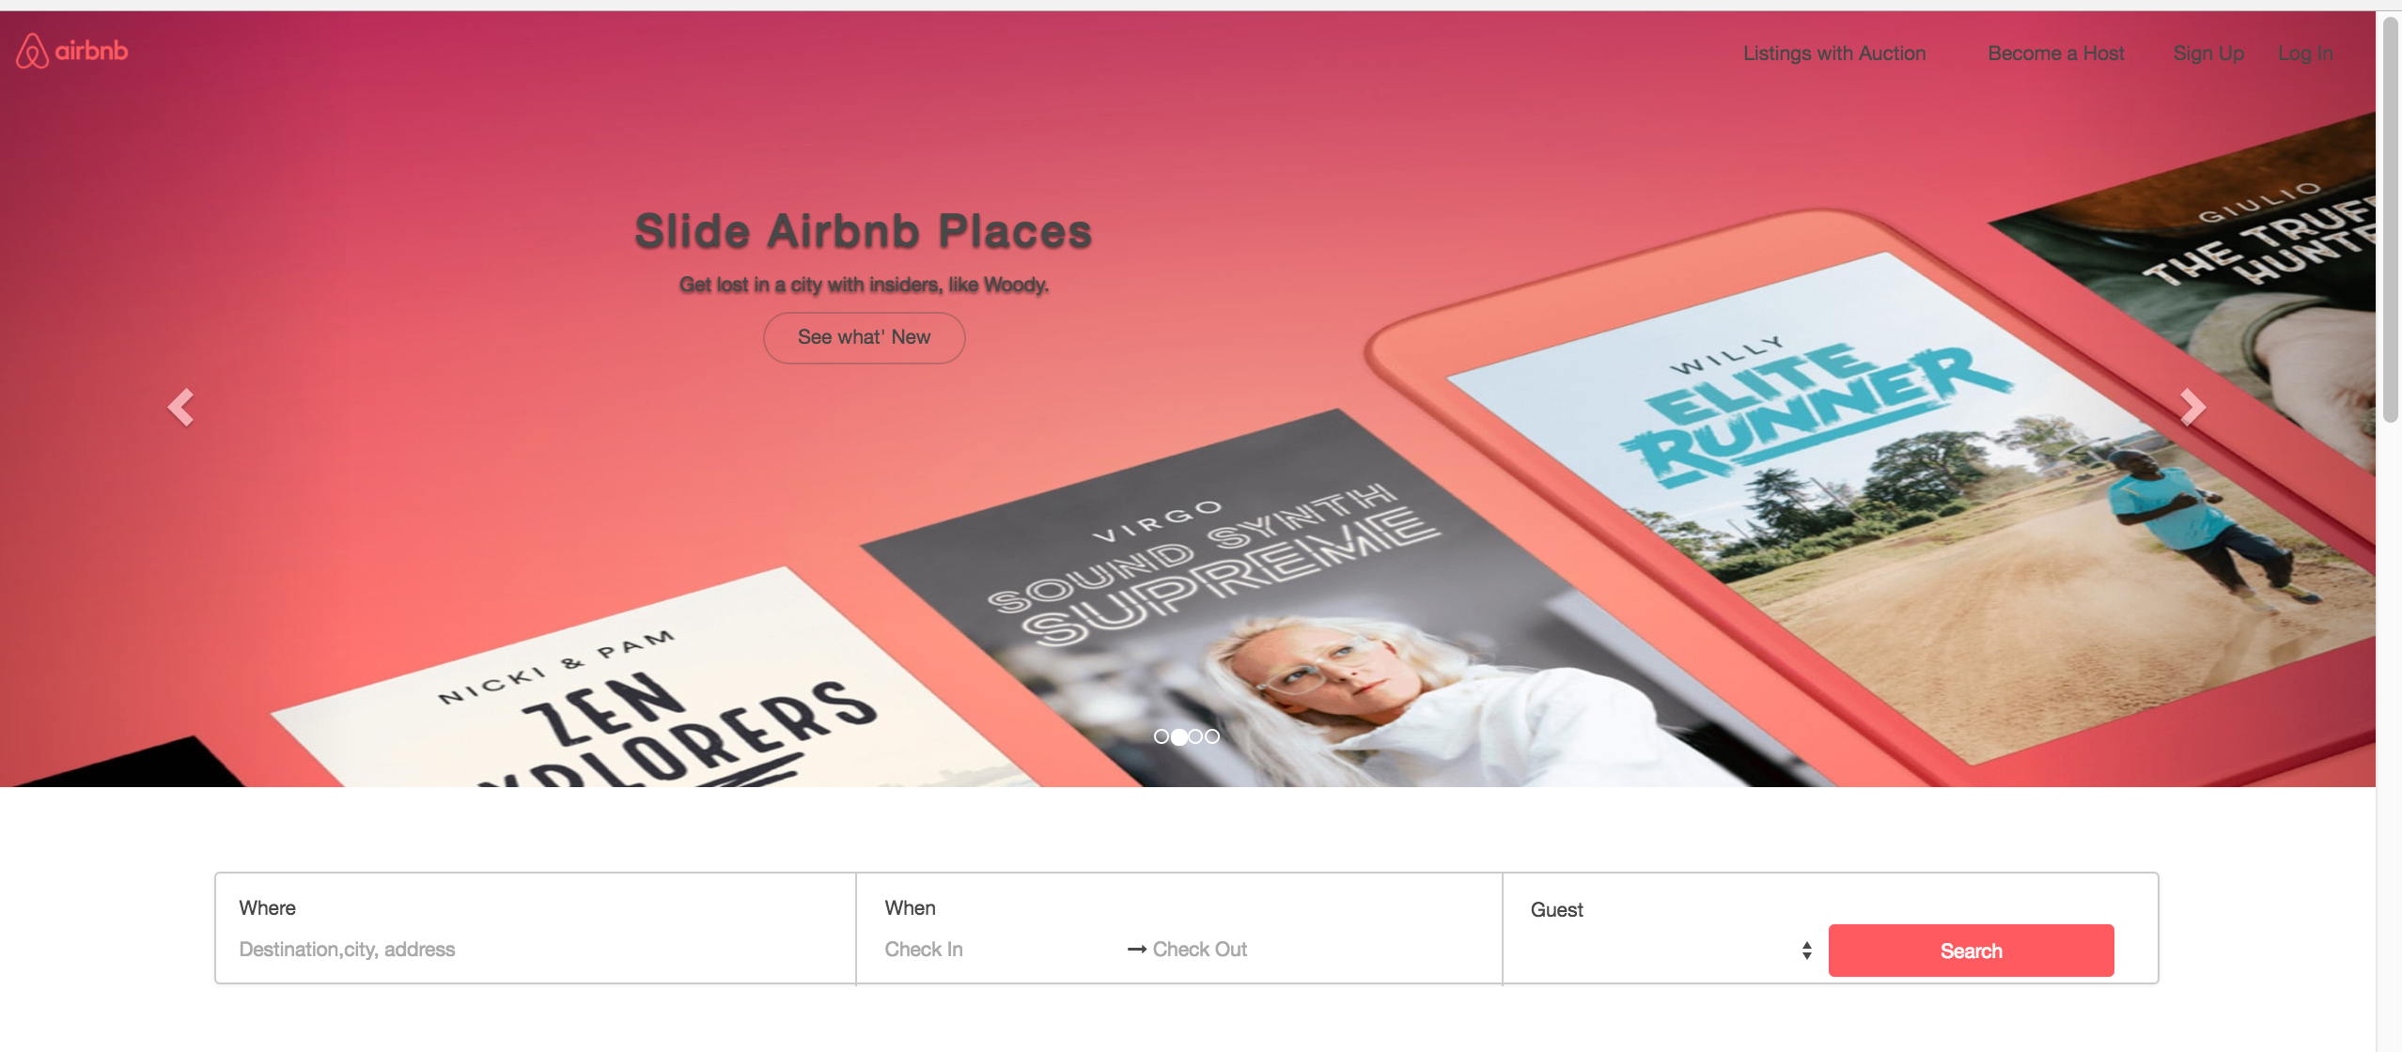

2)All the cities at home page. When customer clicks on any of the cities he is redirected to next page which shows the property under that city or user can search the city from above search bar.

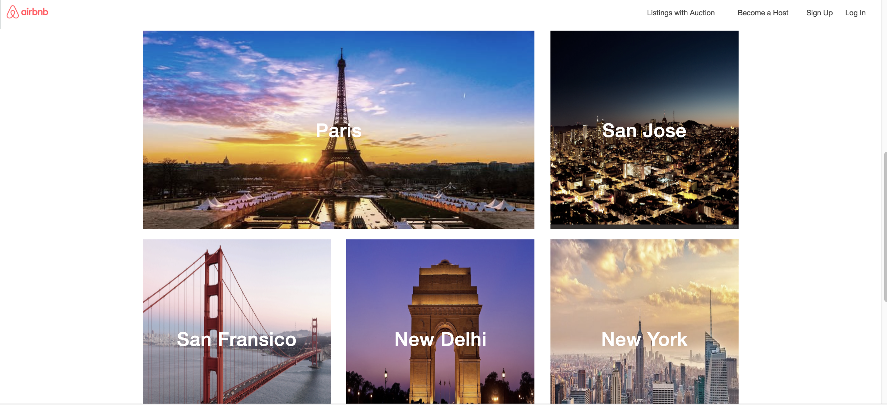

3) Sign Up:

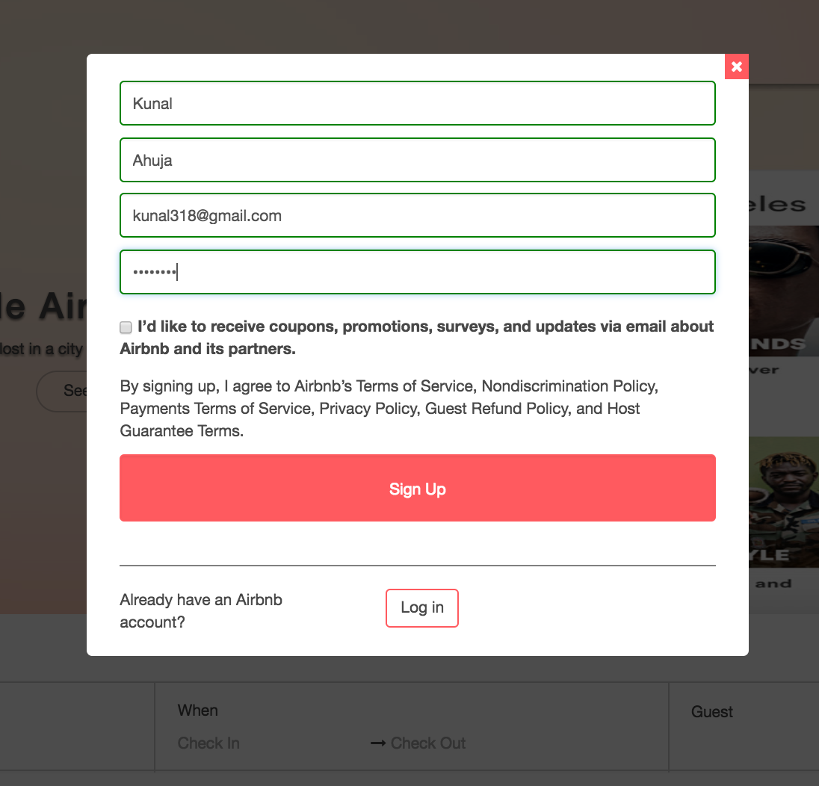

Validations:

If password is less than 8 characters

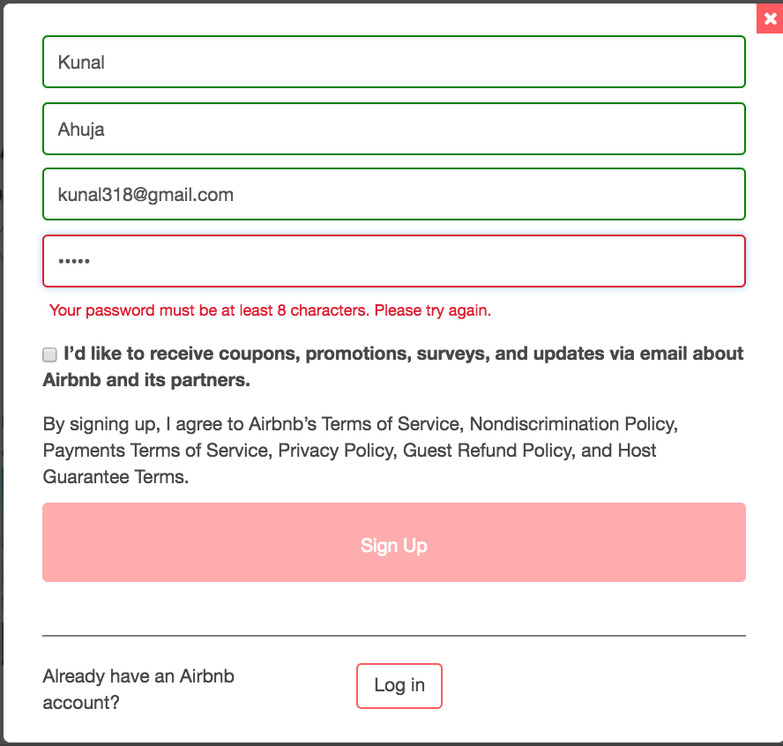

If Email Id is not formatted correctly(missing ‘@’ from emailed)

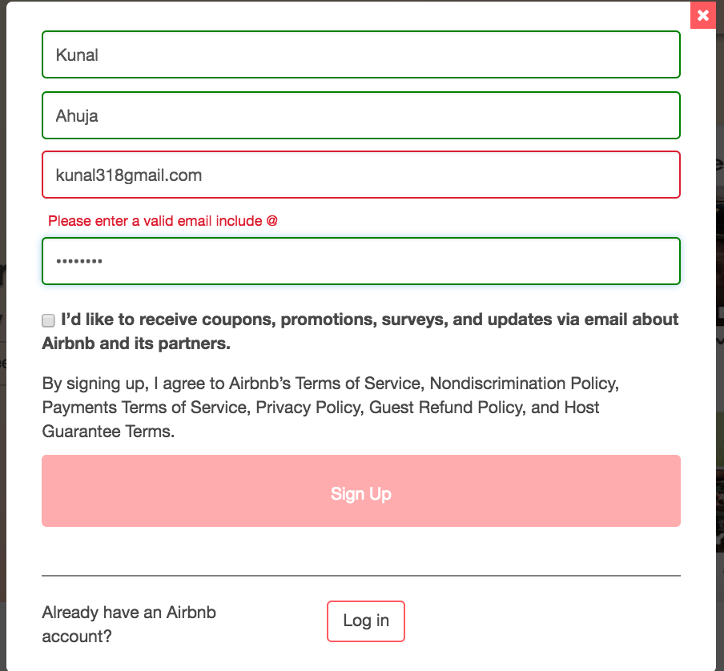

After successfully sign up user is asked to upload profile Pic:

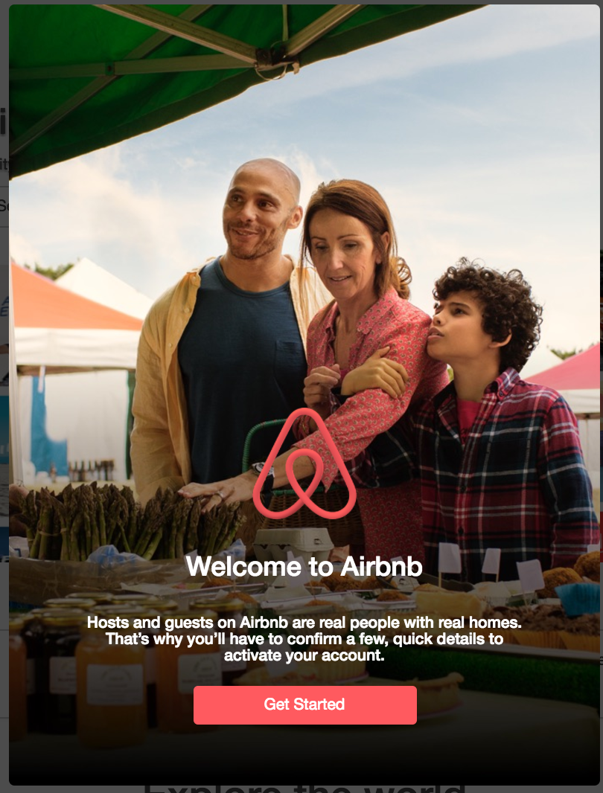

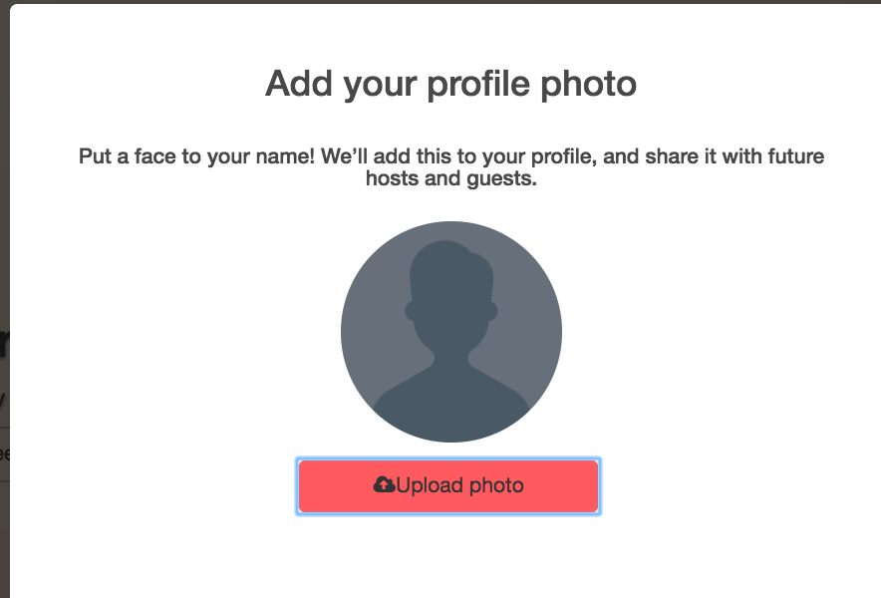

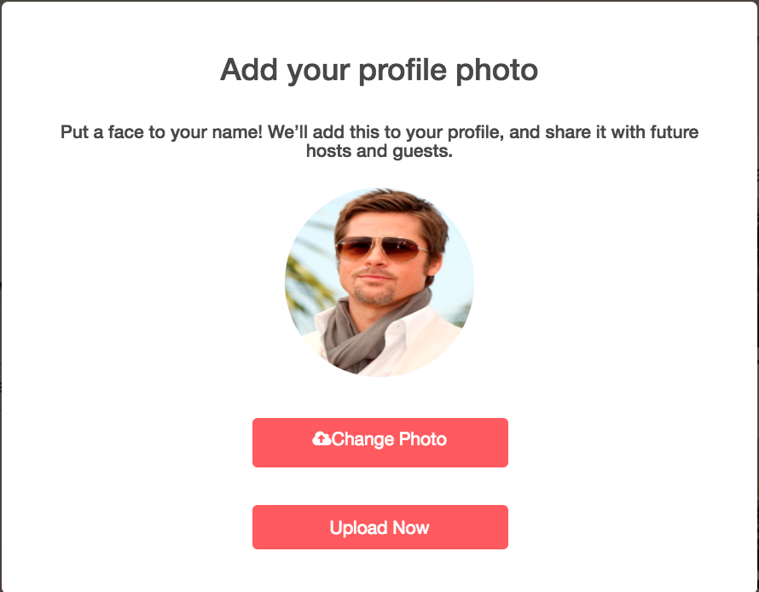

Host Module:

When user wants to host his property:

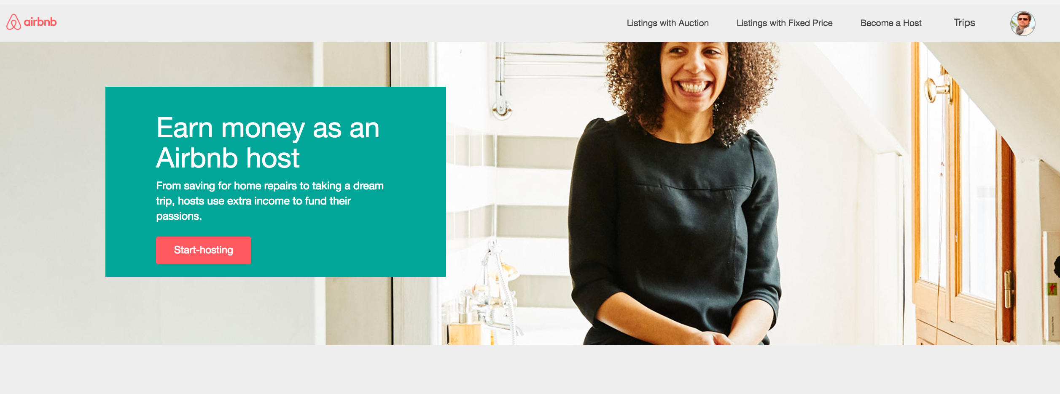

User Enters the type of place:

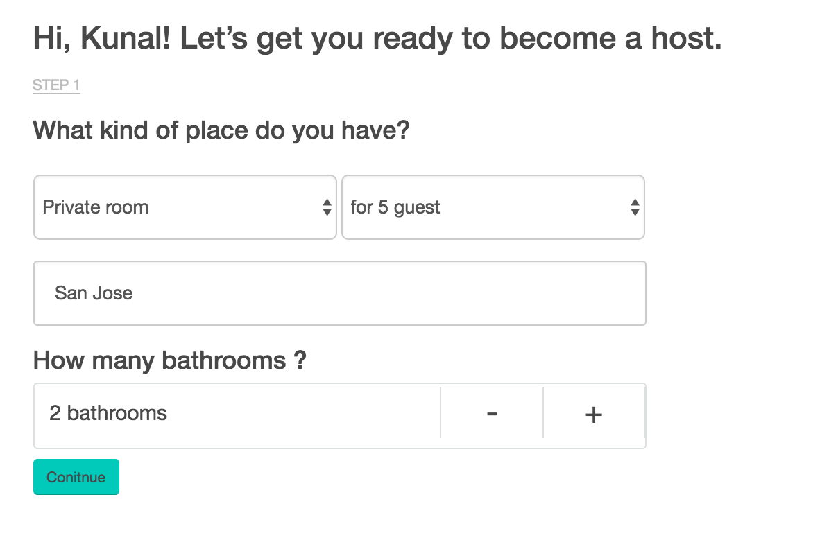

**Address Validation:**

Since this Application’s main business is renting places we have validated addresses using API known as **Address Validator**. If the address is incorrect we suggest the host right addresses as shown in below screenshot. User entered incorrect address we validated from Map and gave him the correct suggestions.

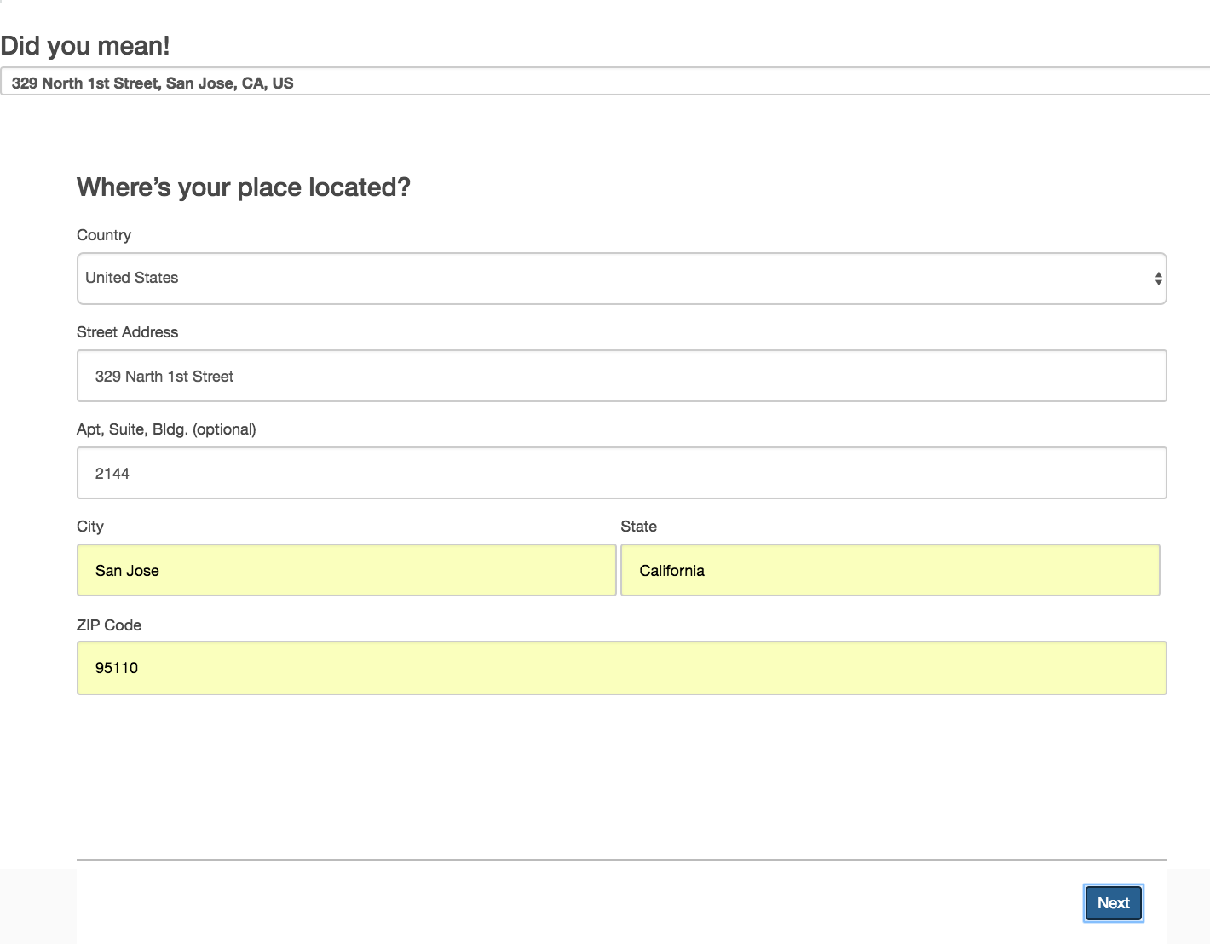

Code:

module.exports.addressValidator =**function**(req, res) {  
 **var** json_responses = '';  
 address = req.body.address + ", " + req.body.city + ", " + req.body.state + ", " + req.body.country;  
 console.log("Address " + address);  
 **var** unknownAddresses = [];  
 addressValidator.validate(address, addressValidator.match.unknown, **function** (err, exact, inexact) {  
 **if** (err) {  
 console.log('in error');  
 json_responses = {'statusCode': '401', 'error': 'Please enter valid data'};  
 } **else** {  
 **if** (exact != '' && exact != **null**) {  
 console.log('in match found');  
 json_responses = {'statusCode': '200', 'addressCoordinate': exact[0].location};  
 } **else** {  
 unknownAddresses = _.map(inexact, **function** (a) {  
 **return** a.toString();  
 });  
 console.log('in no match found');  
 json_responses = {'statusCode': '400', 'suggestedAddress': unknownAddresses};

User can select amenities available in his property:

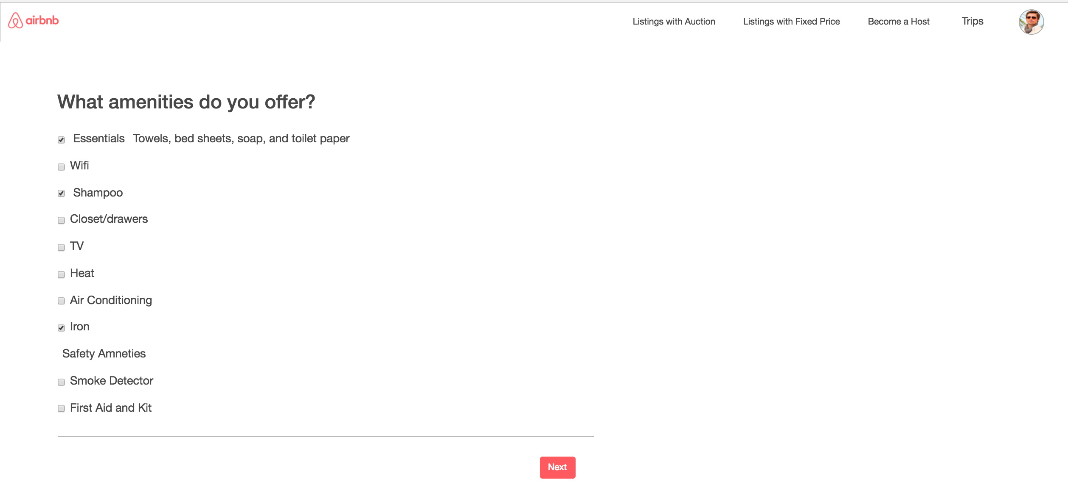

Name of property:

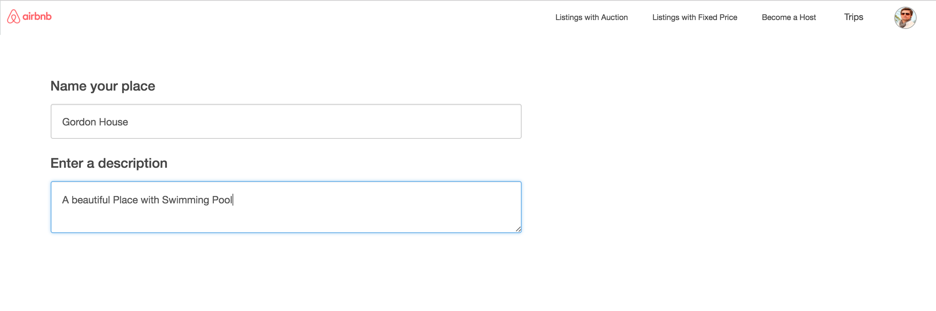

User can select if property is available for fixedPrice or Auction:

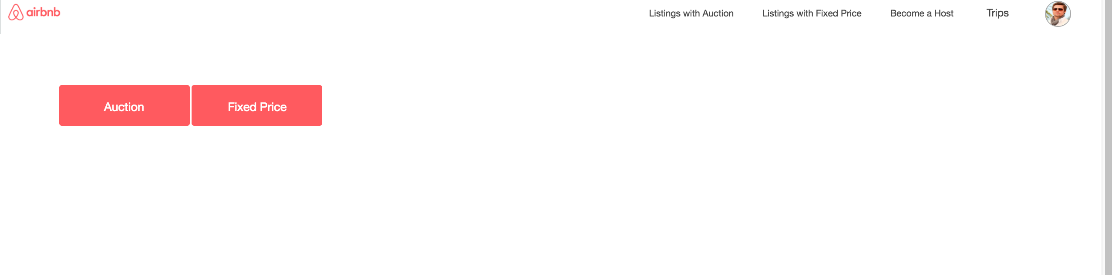

Per day rent of the property and available dates

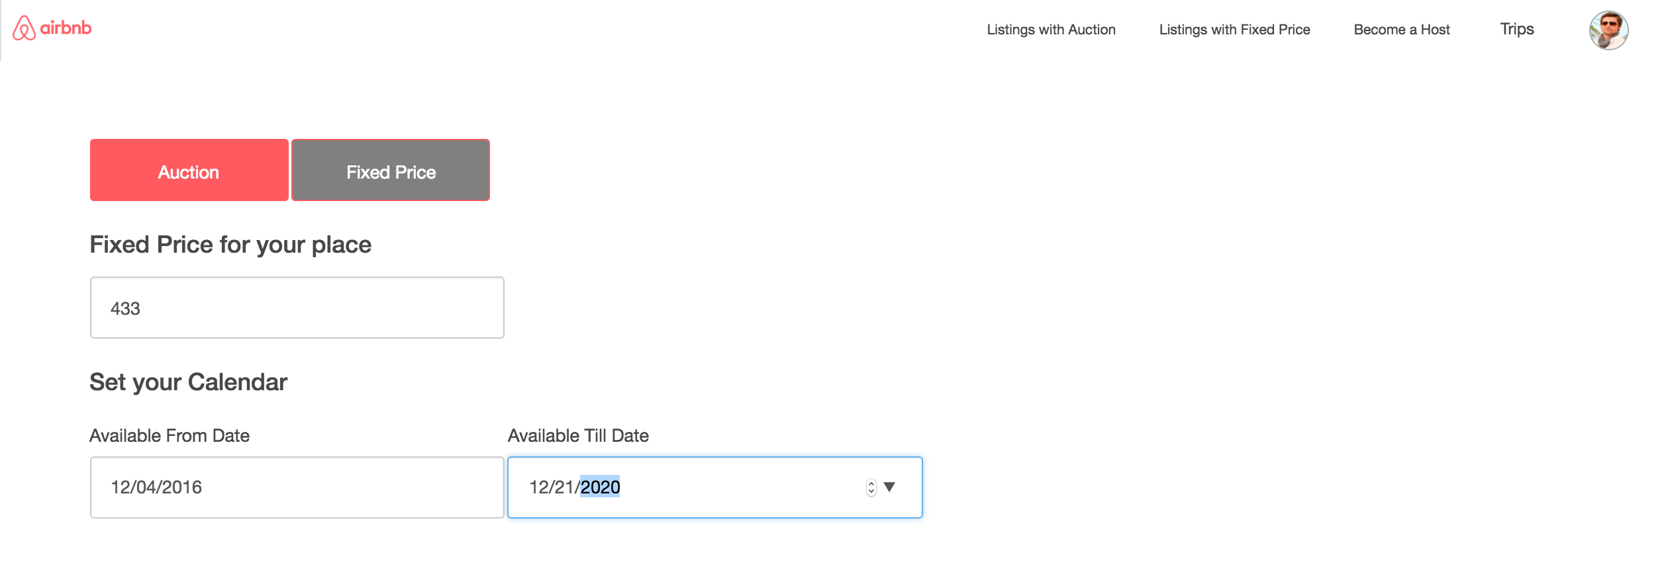

If user selects available from date less than current date message is thrown:

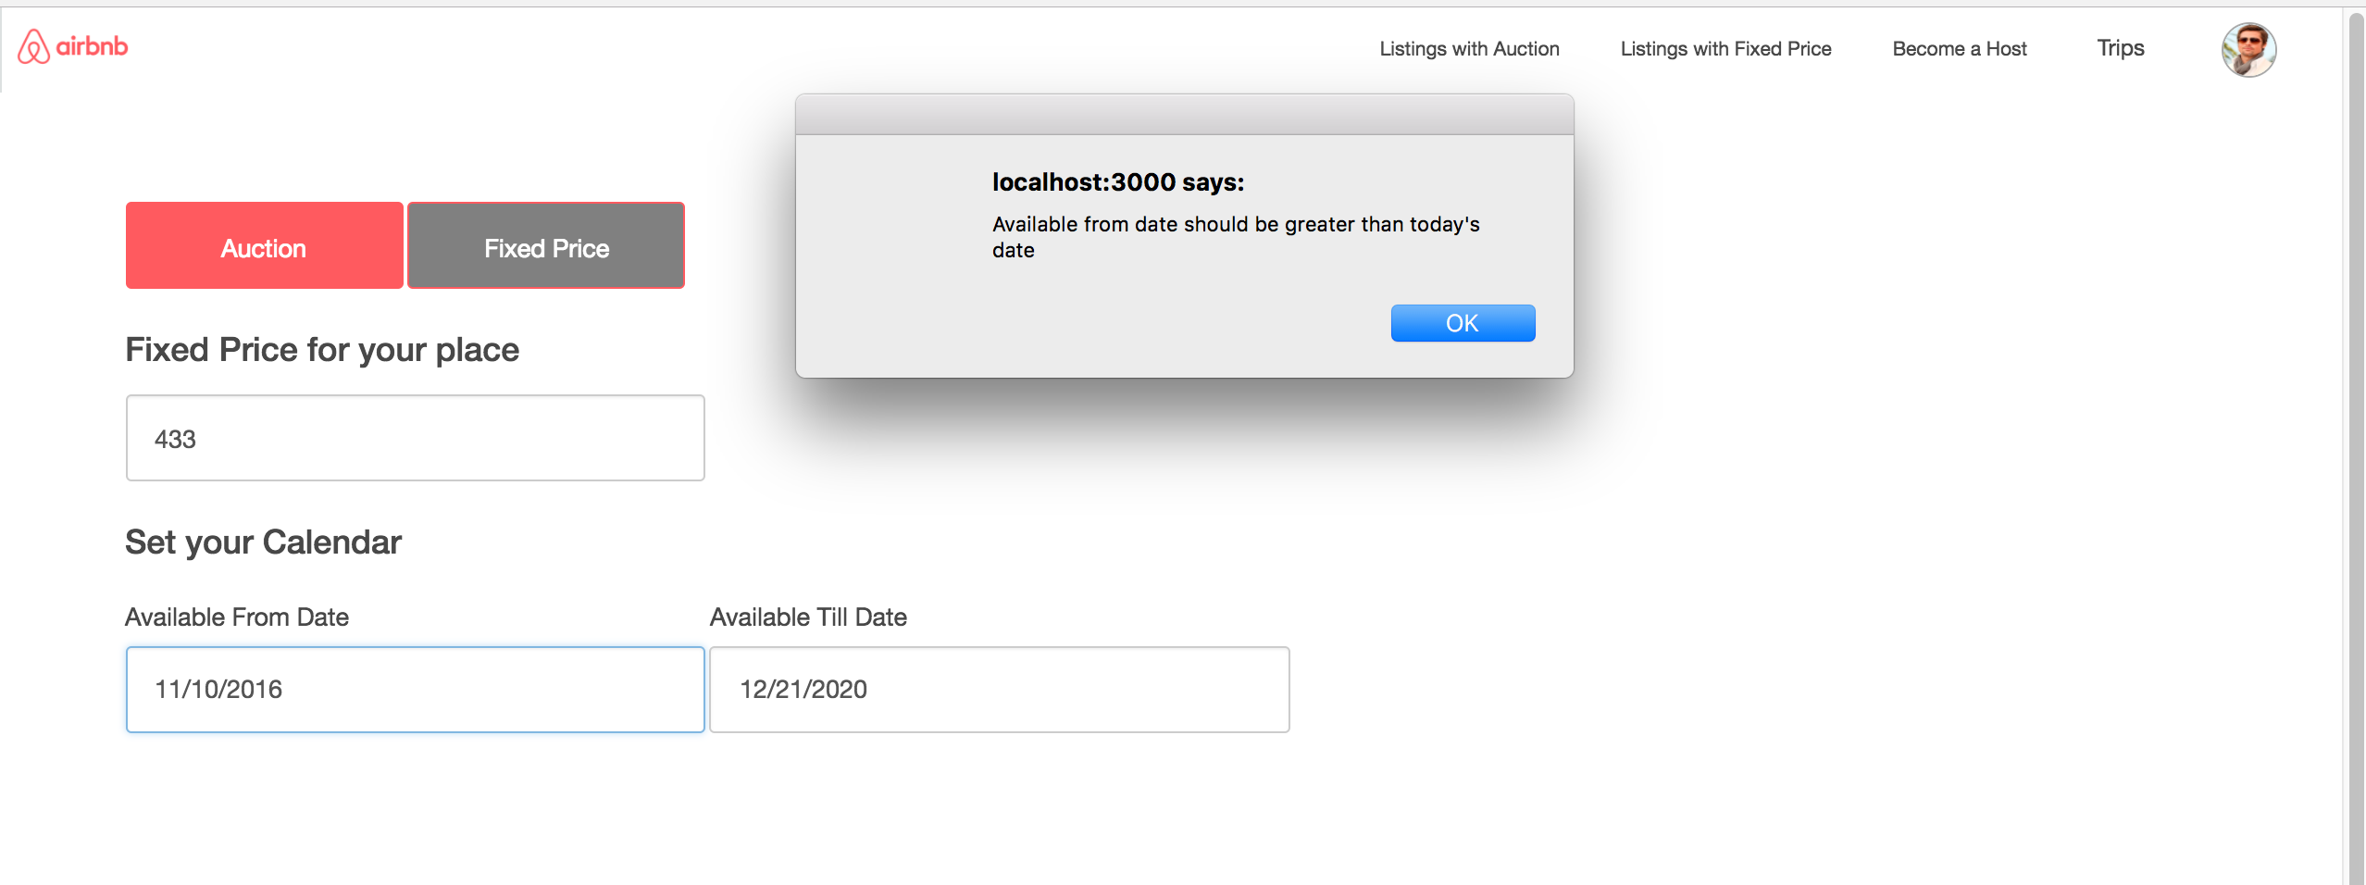

User can upload images of his property. We have restricted upload image limit to 24 following Airbnb.



Now after this request of this property is sent to Admin for approval. Once admin approves then only property will be visible to other users for booking.

**Trip Module:**

User can click on any of the cities or search for the properties in the city:

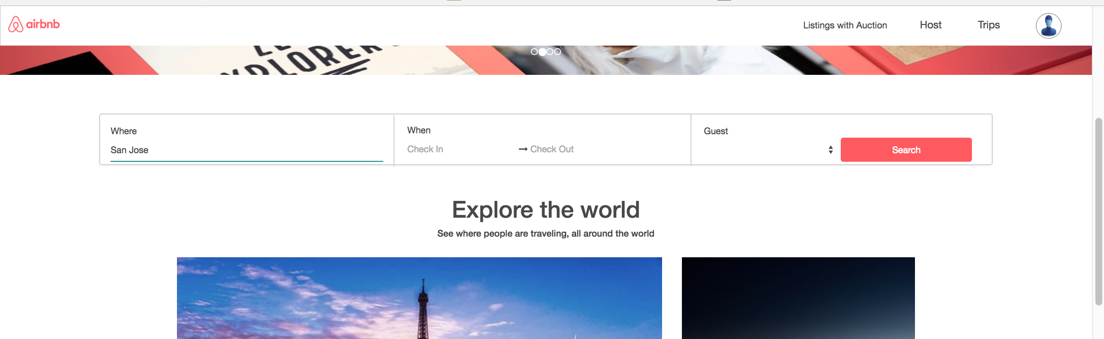

User can apply for the filters from the below screen. User sees all the properties. All the filters are function and are applied on click.

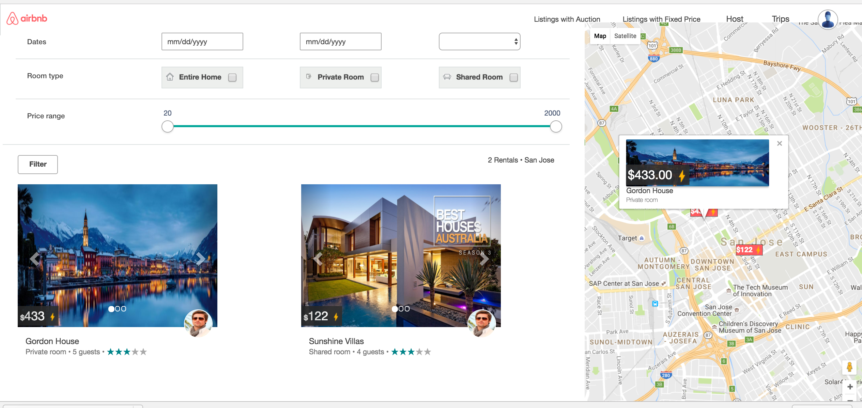

user can also see the ratings for each and every property.

Google Map:

User can see prices of each property on Map and those objects are clickable providing images of that property

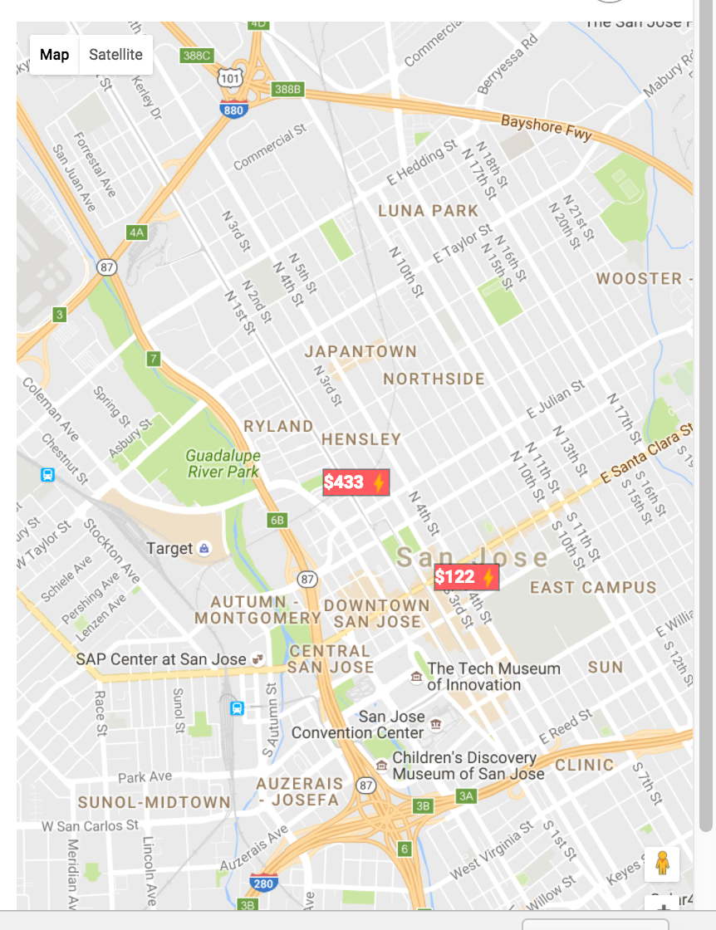

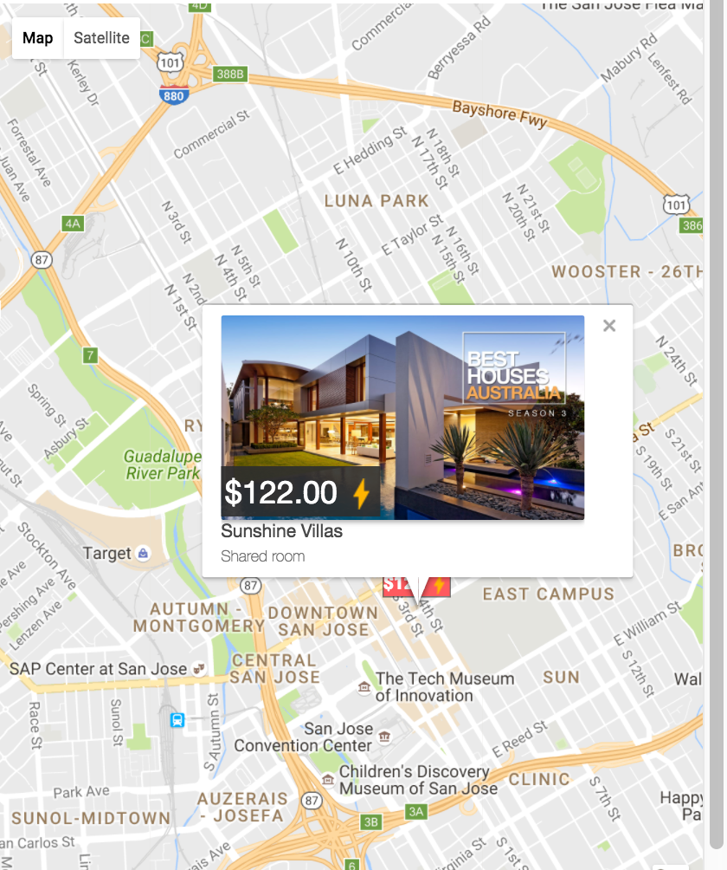

Once user clicks on any property he can view all the details of the property. He can select the checkIn and checkout dates.

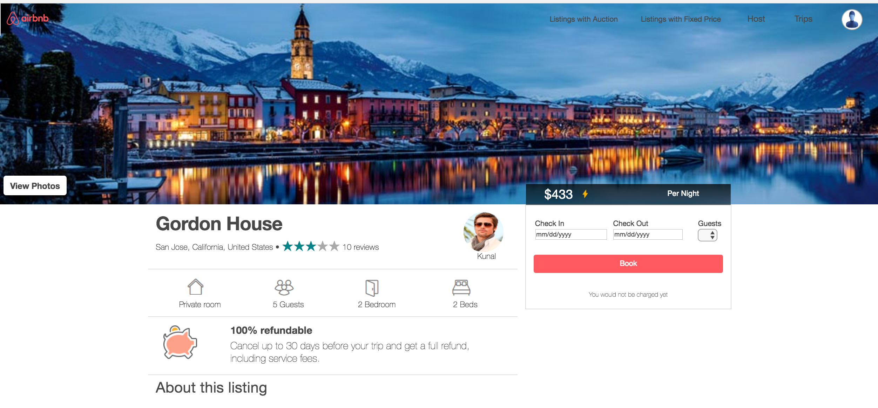

User can view all images of the properties. We have used carousel to display images.

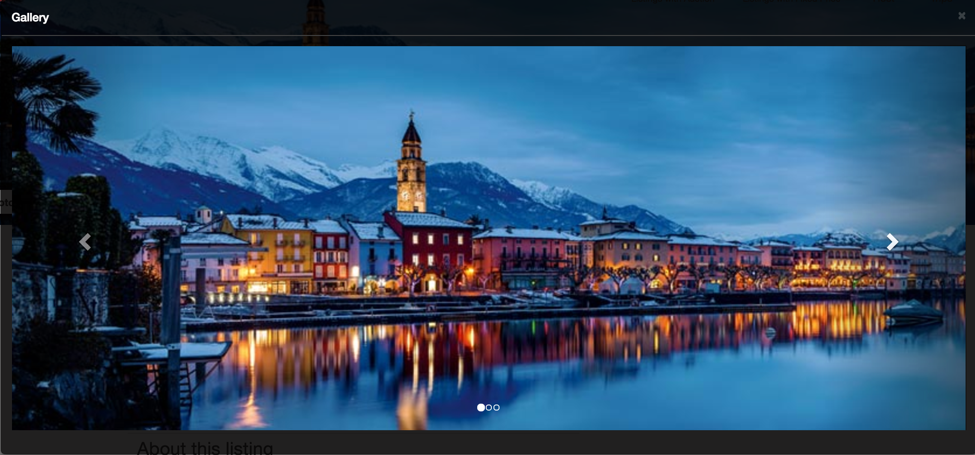

User can see detailed review of the properties by other users along with the real images of the properties posted by the users.

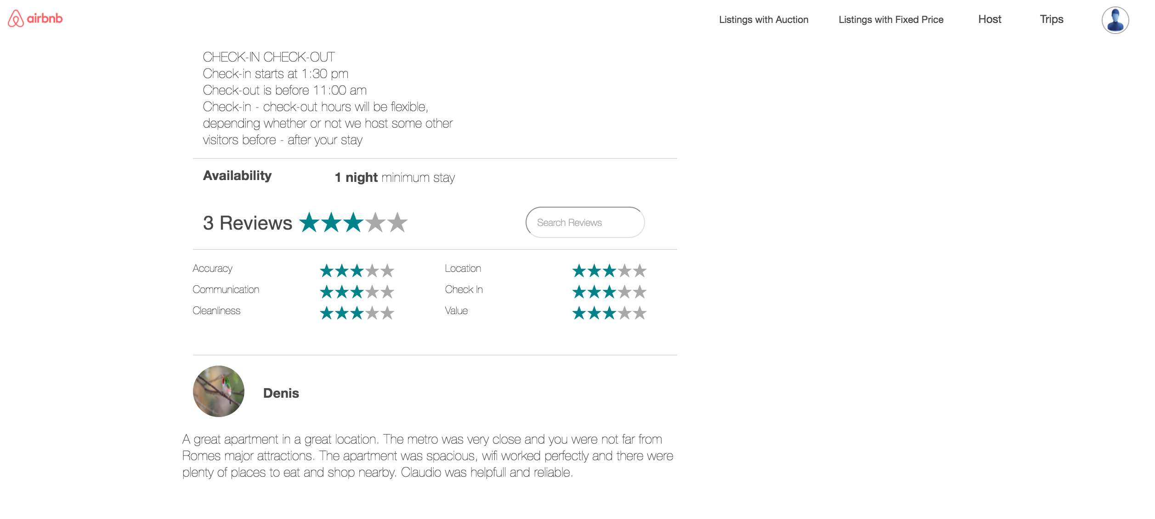

We have applied all possible validations for selecting dates:

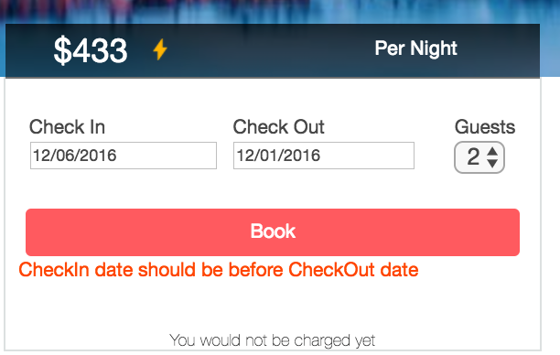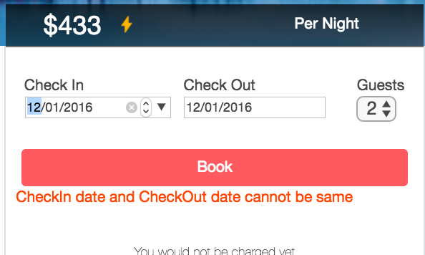

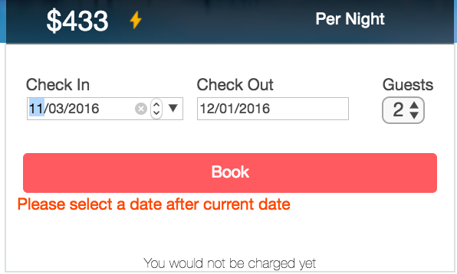

Since user has selected while listing his property that property is available only after 2016-12-06 and same goes for checkout validation as well.

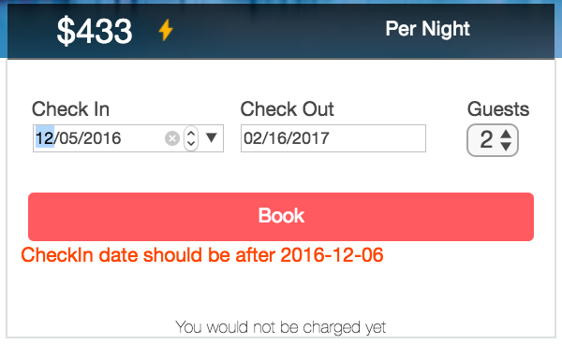

Once user selects the correct dates, he is redirected to final page where he can leave comments for the host and once he sends the request, request goes to approval for host and user is redirected to ‘view trips’ page.

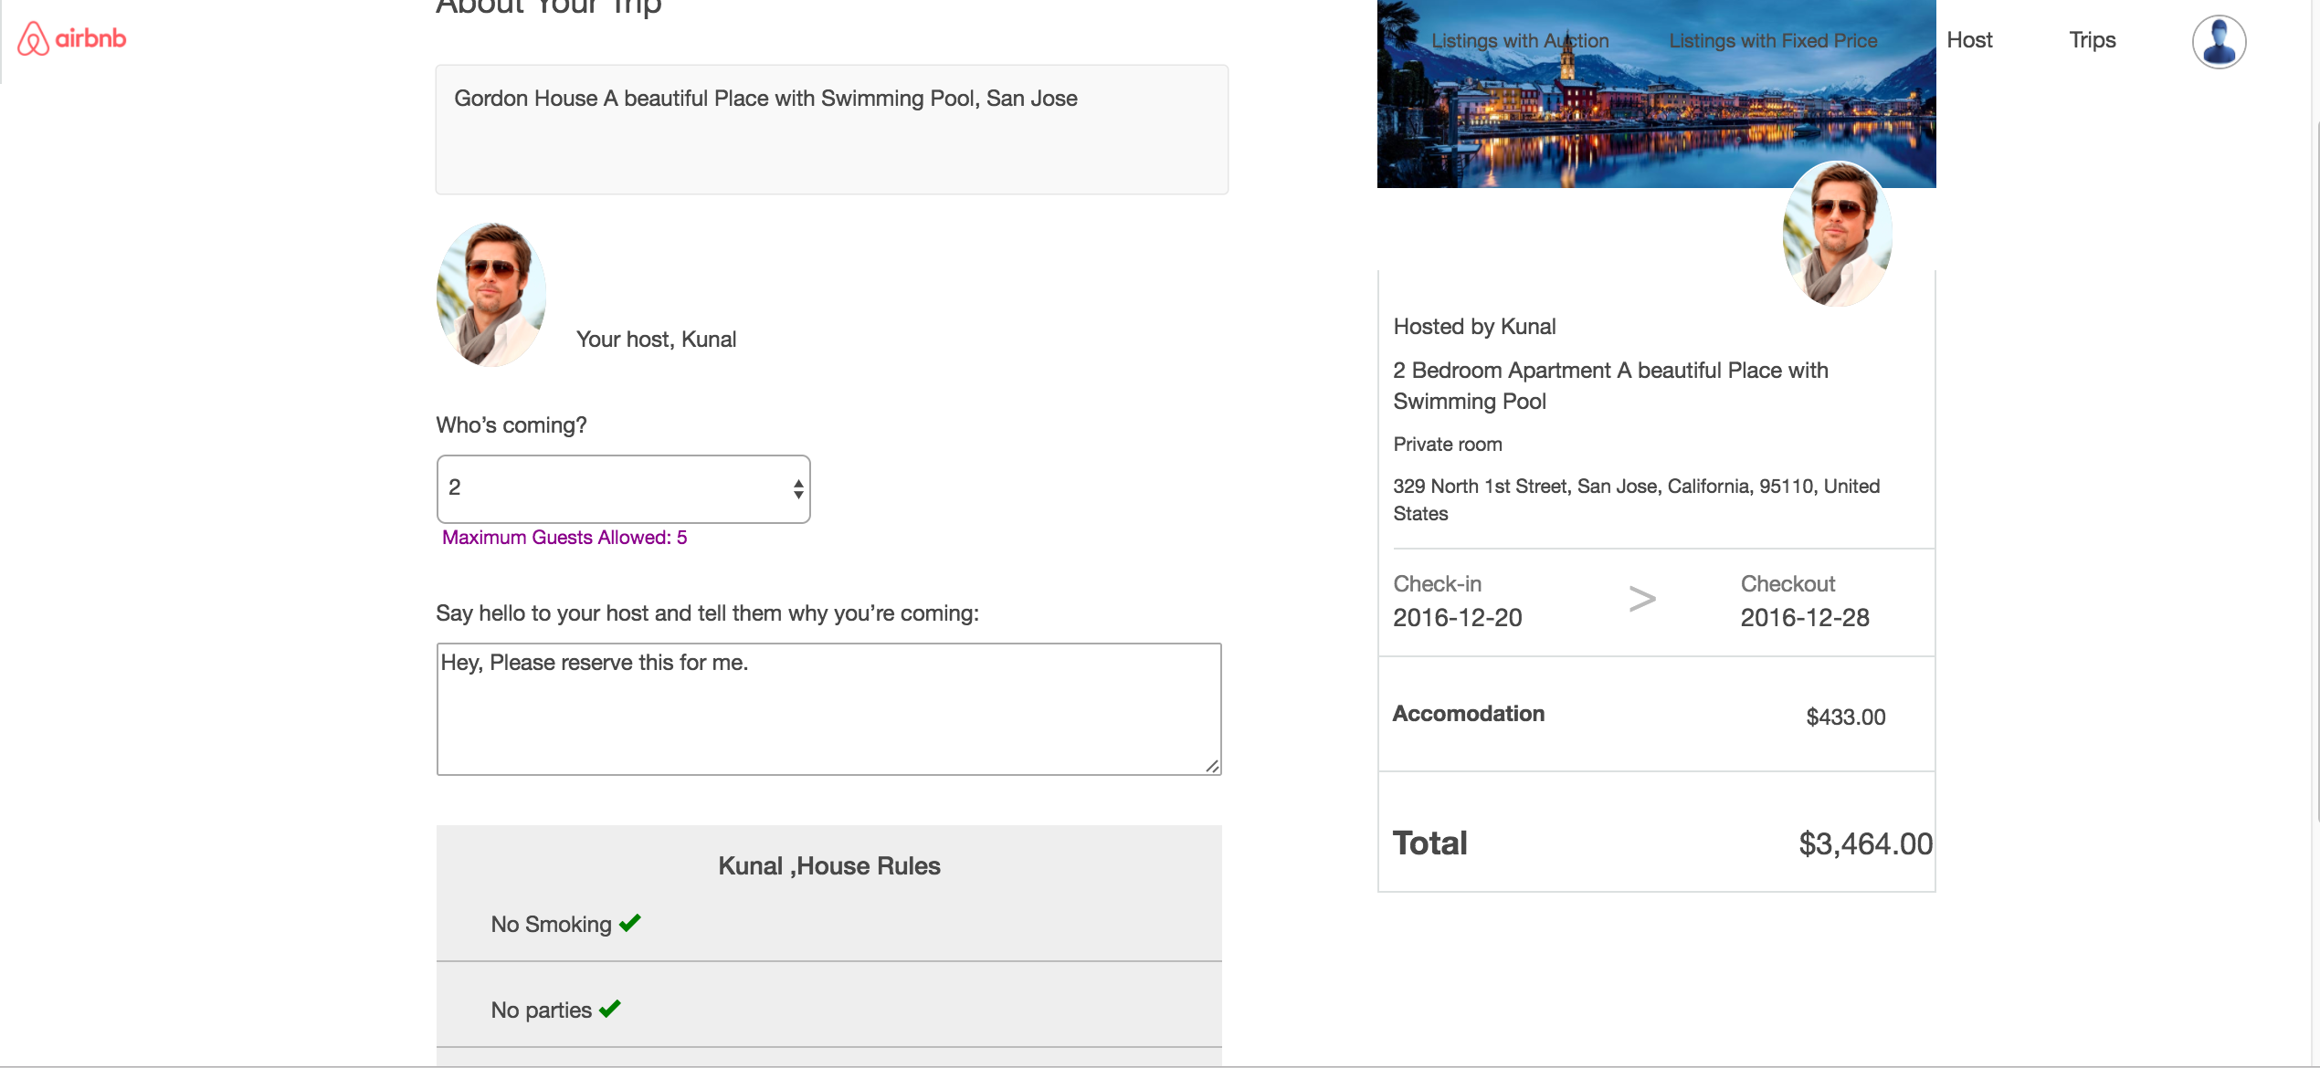

Booking Successful.

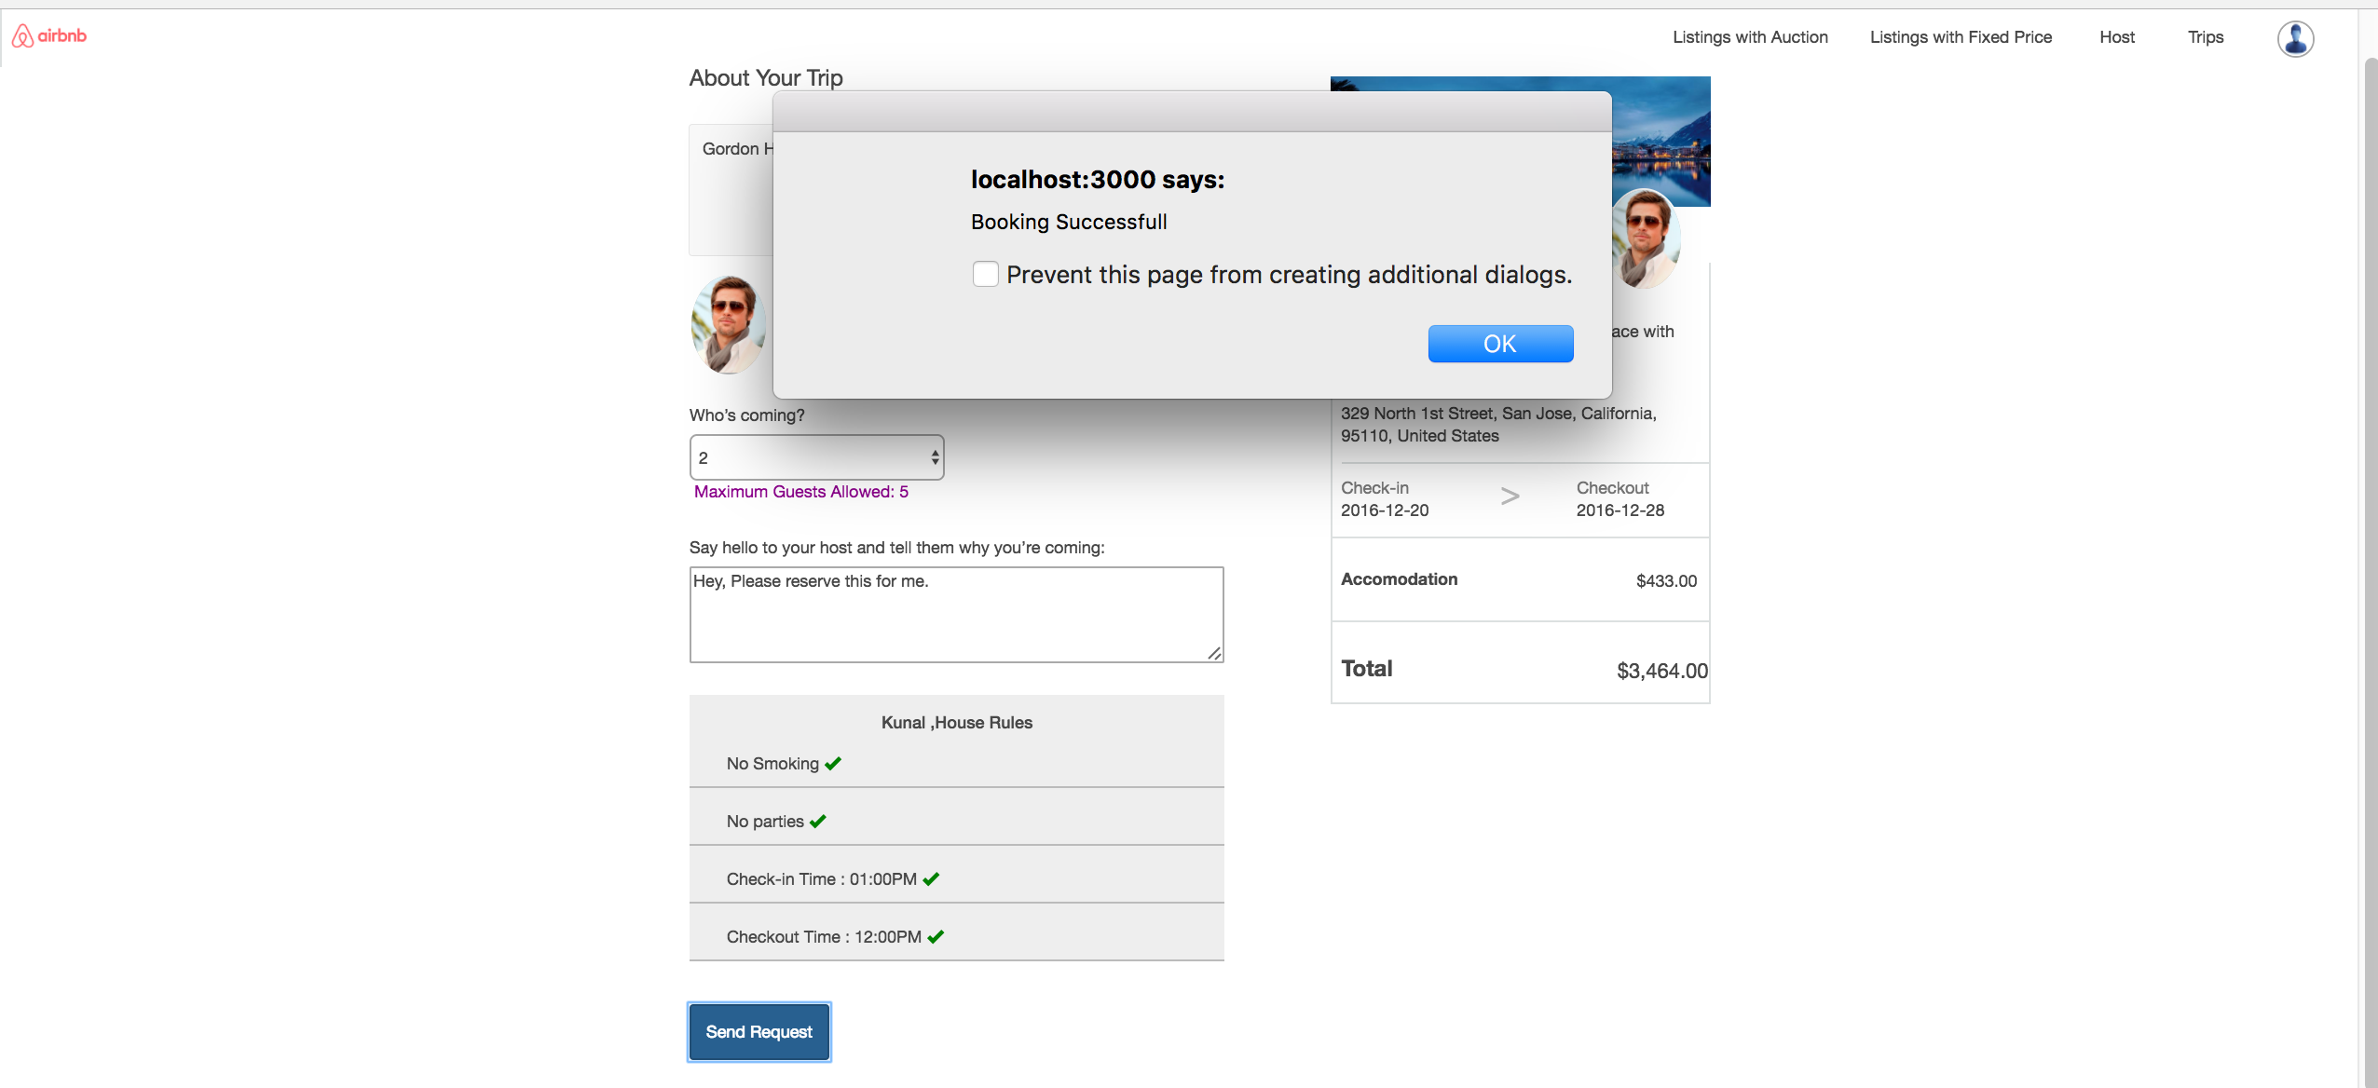

View Trips

Unless hosts approves it user does not gets to pay and user can edit and cancel trip. Similarly user can see his previous trips and trips which he bid for.

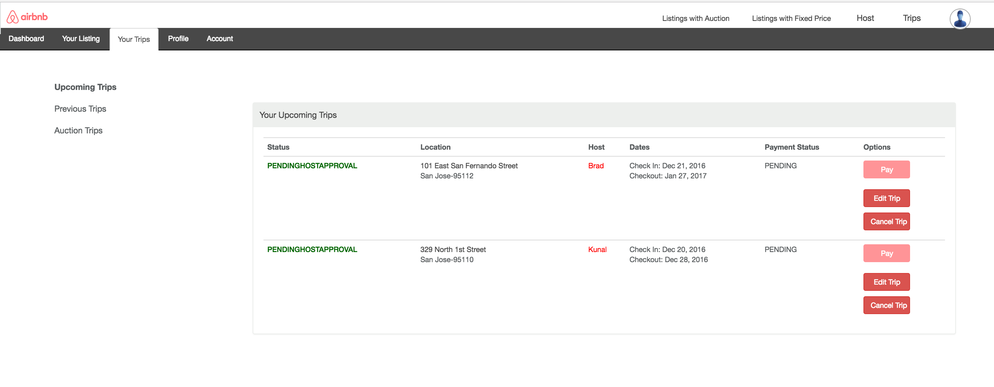

If admin approves the request, Pay button will be enabled and user can pay the amount.Once user clicks on Pay he gets an option to pay the amount. If user has already added the credit card in his profile the fields are already populated:

We have also applied the checks, credit card number should be 16 digits, cvv should be 3 digits and expiry should be greater than today’s date.

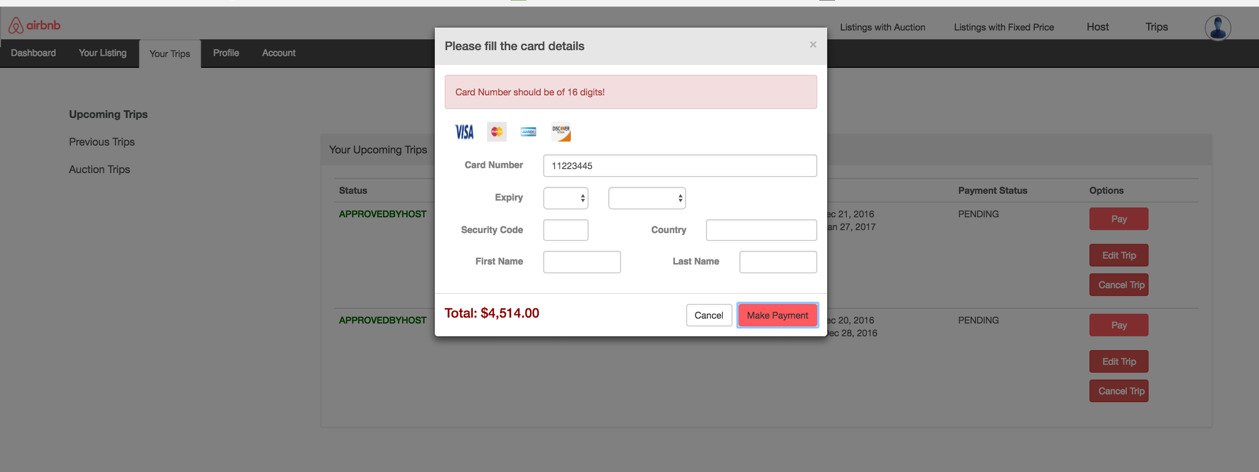

User can view the bill once he pays the amount. View Bill Button is made visible after paying.

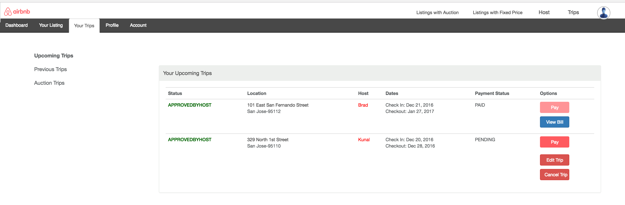

Billing

Our Bill has covered all the fields like property name, Receipt number(ssn format), dates, amount, host, guests etc..

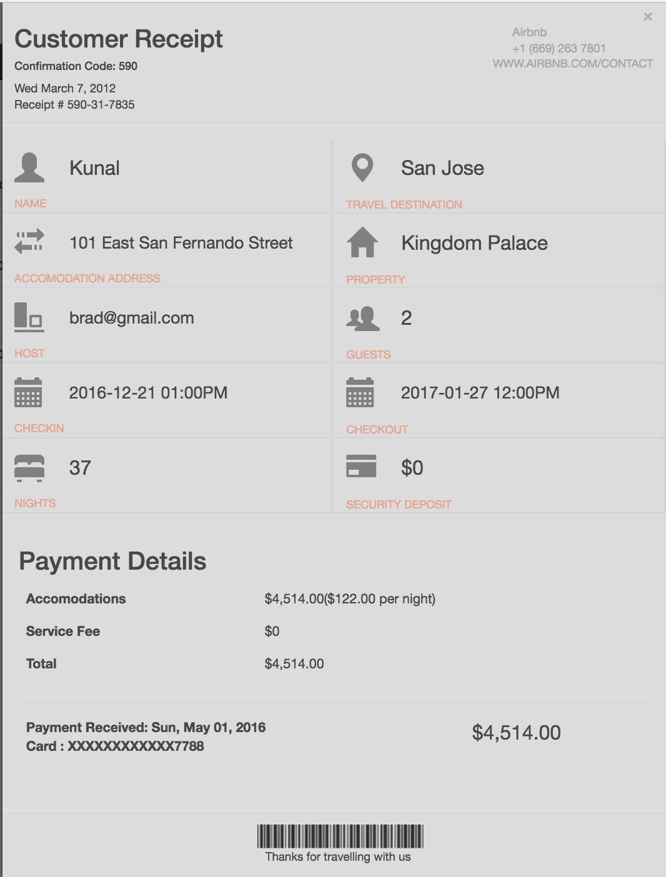

User Profile:

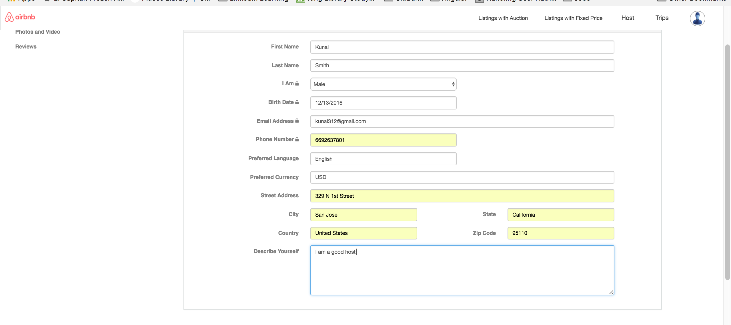

User can view his profile.

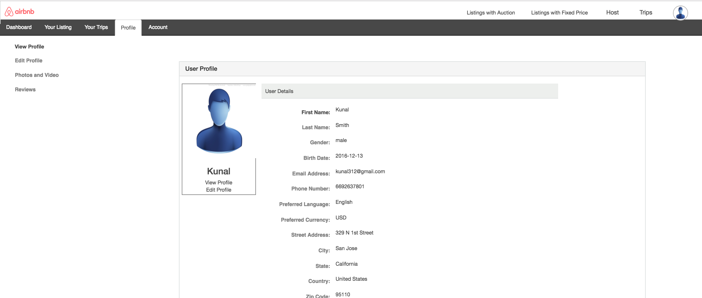

User can upload his profile pic and video.

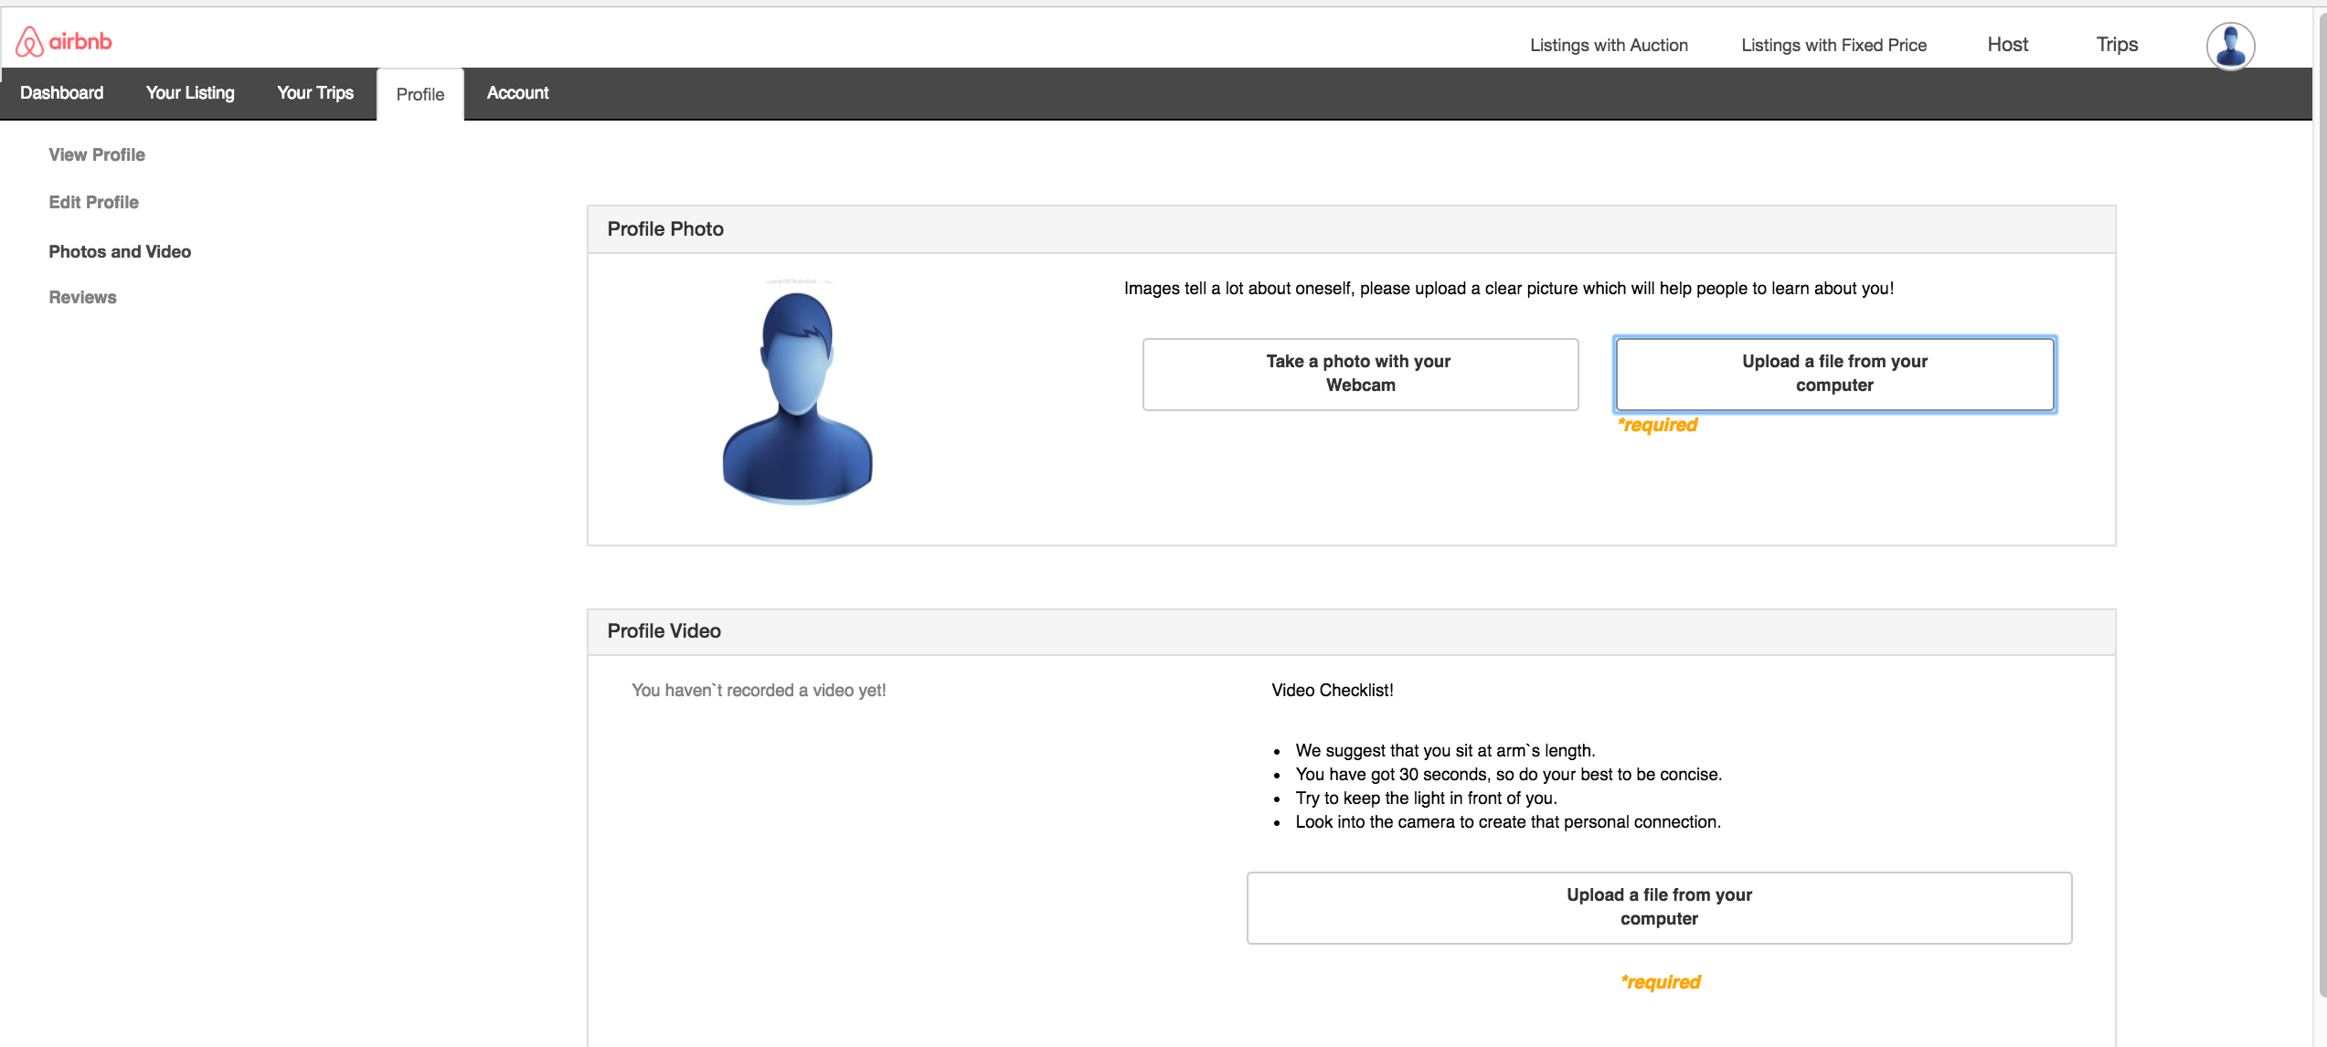

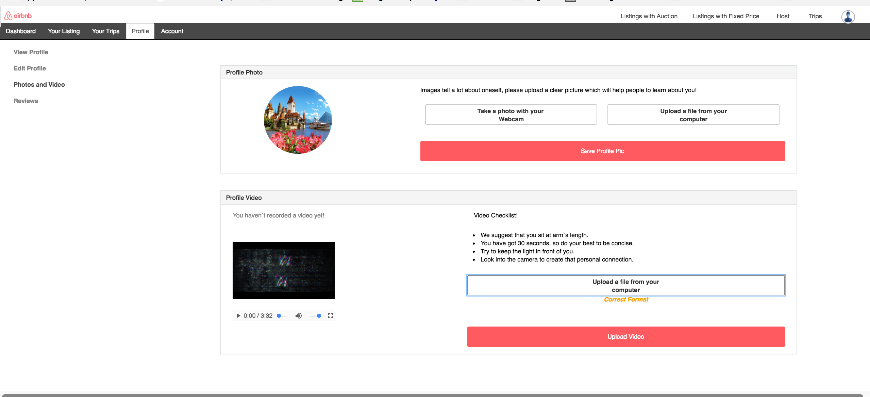

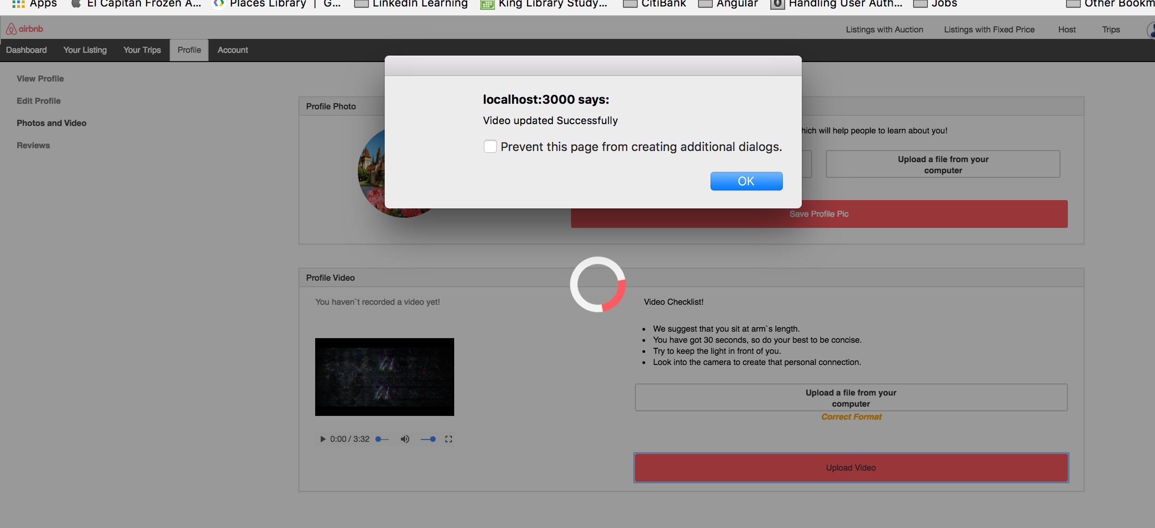

Reviews:

User can review the properties and host once the trip gets completed.

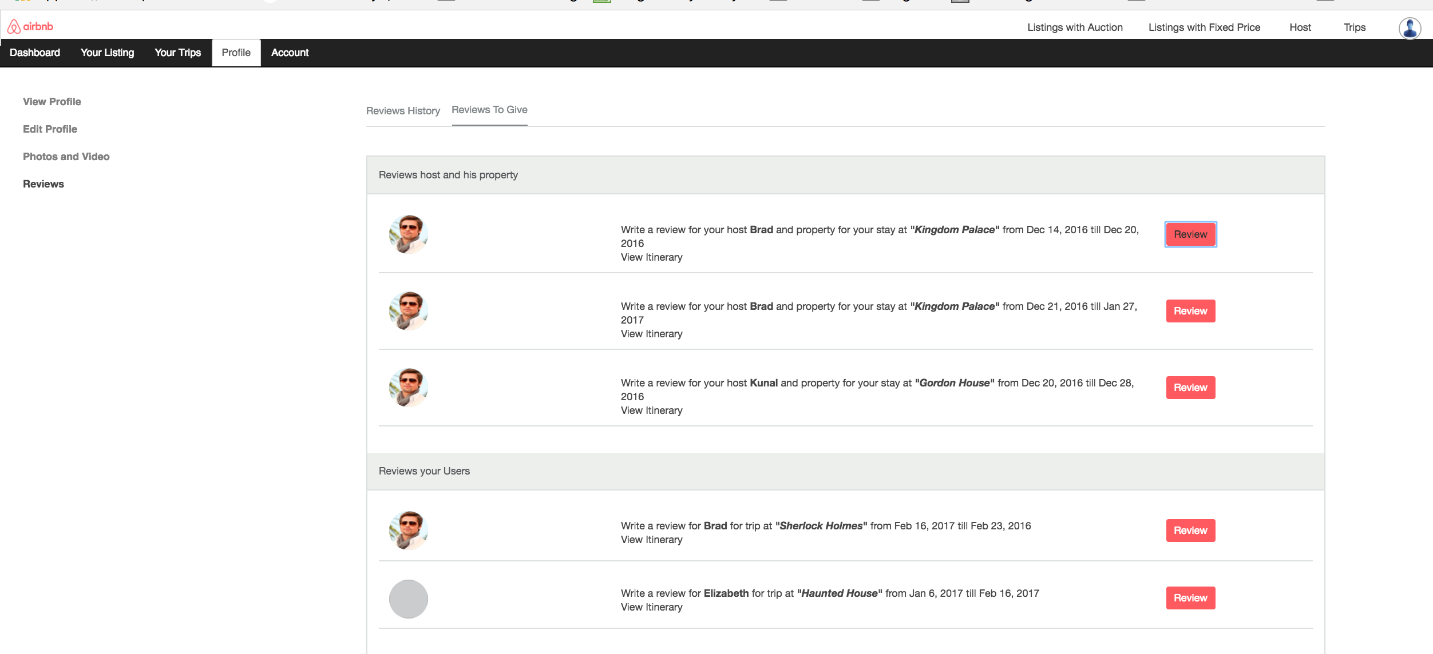

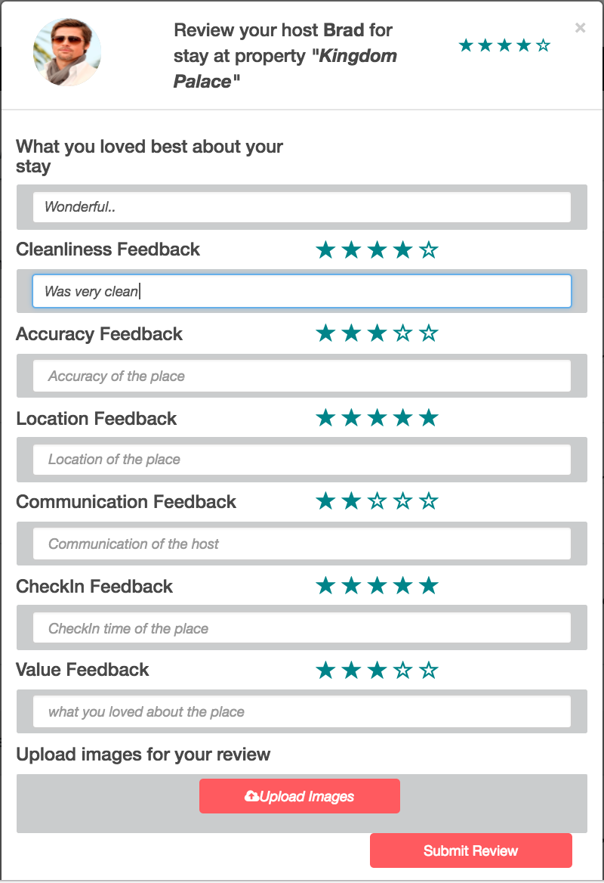

User can also upload real images:

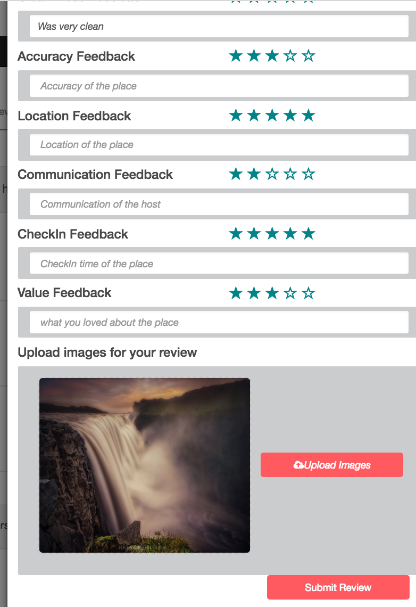

User can add his credit card details:

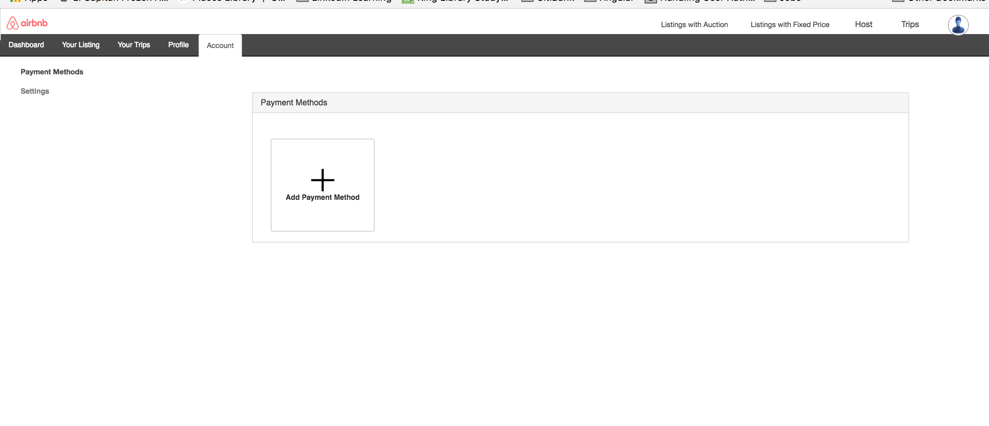

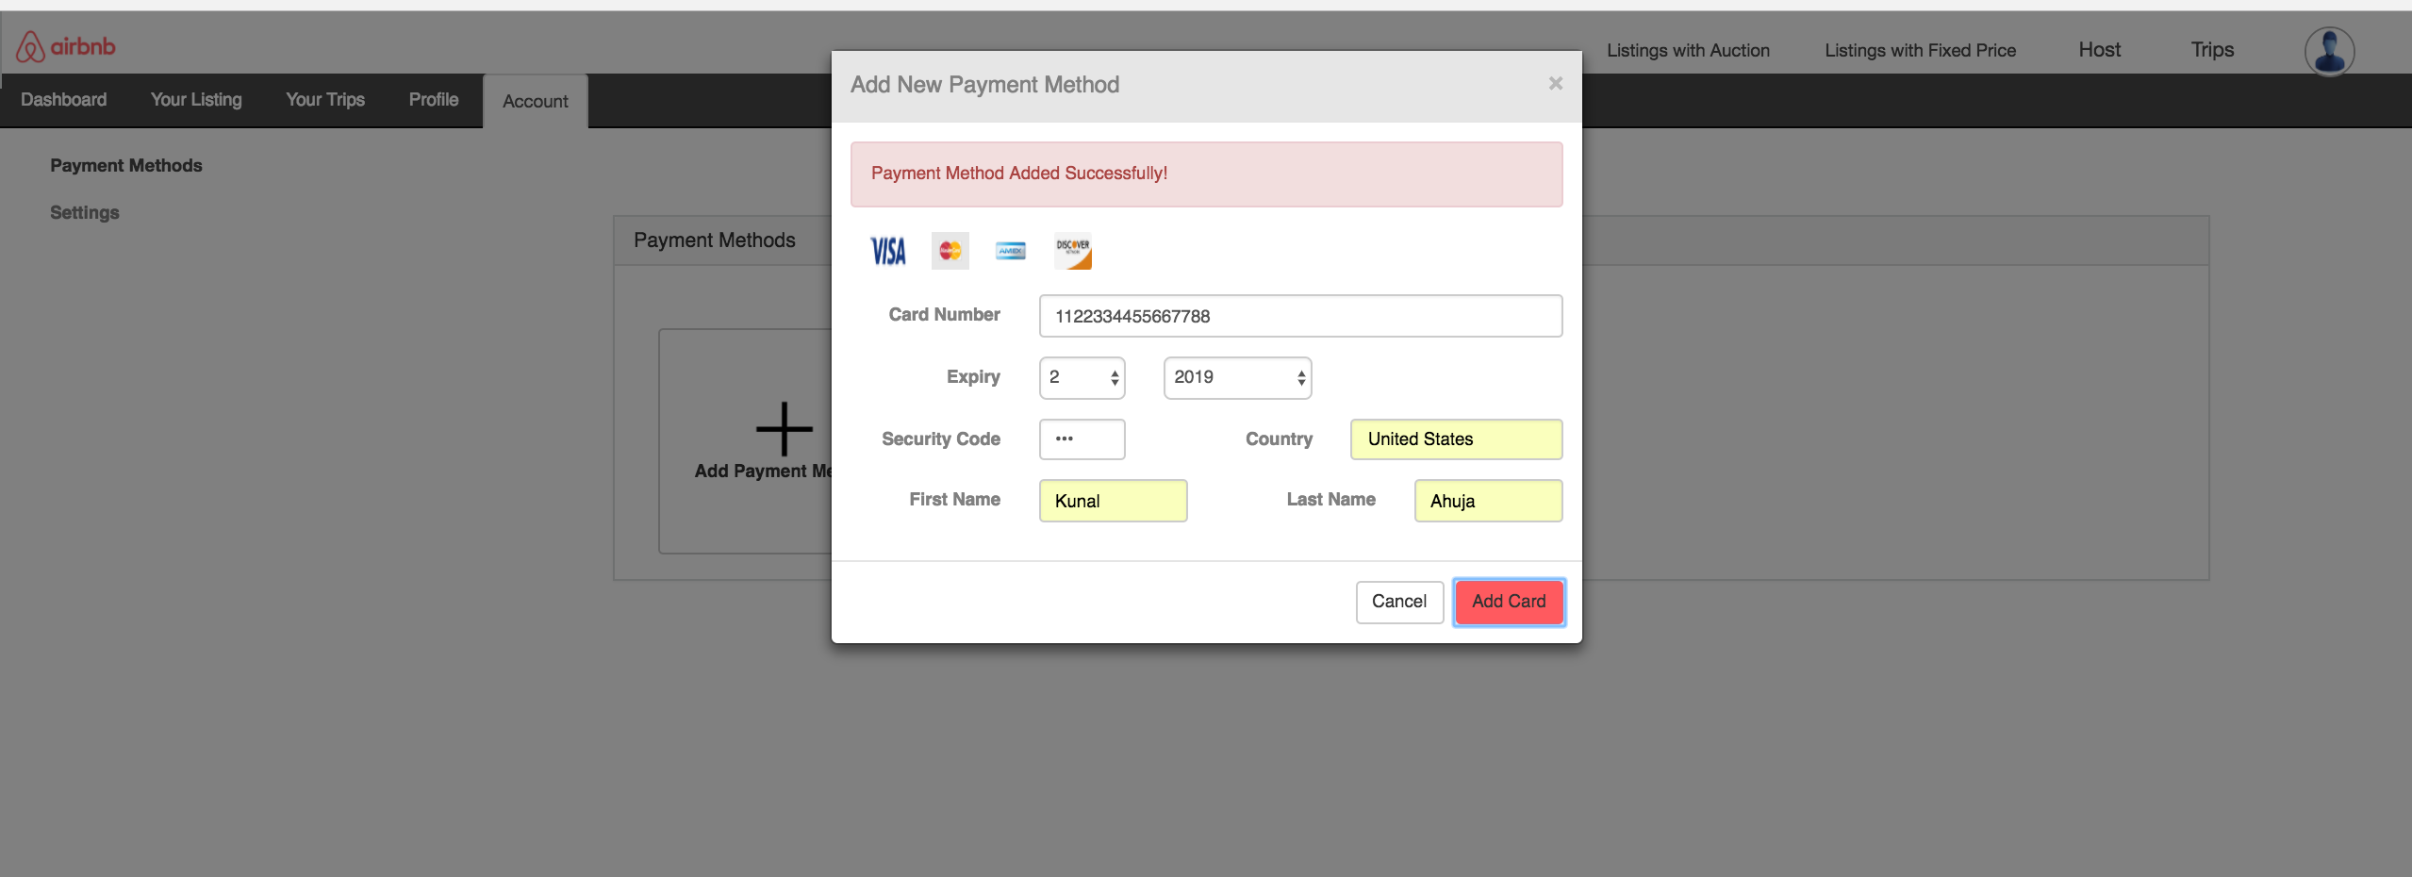

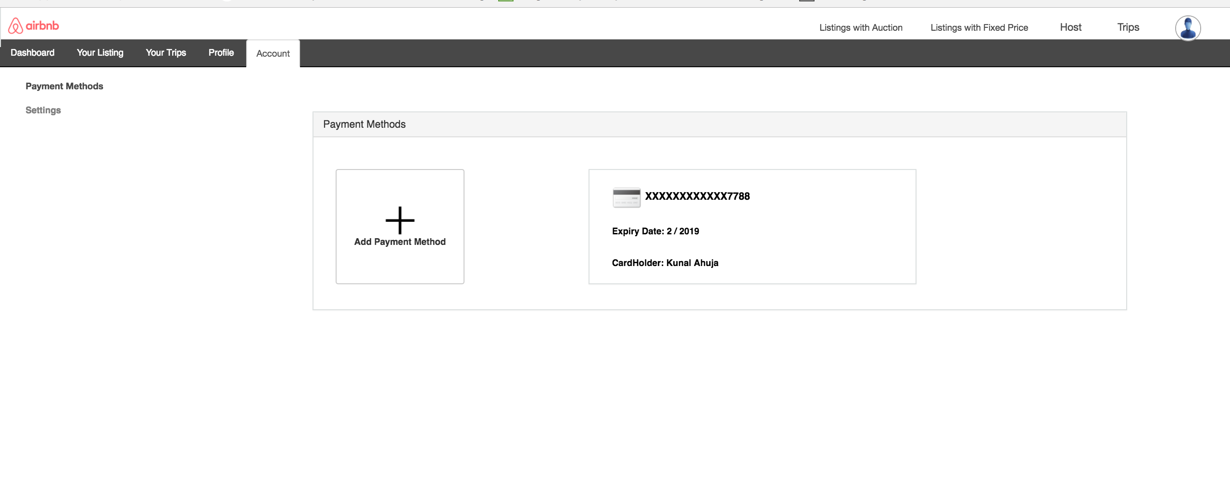

User can manage his listings, check who have booked his properties.

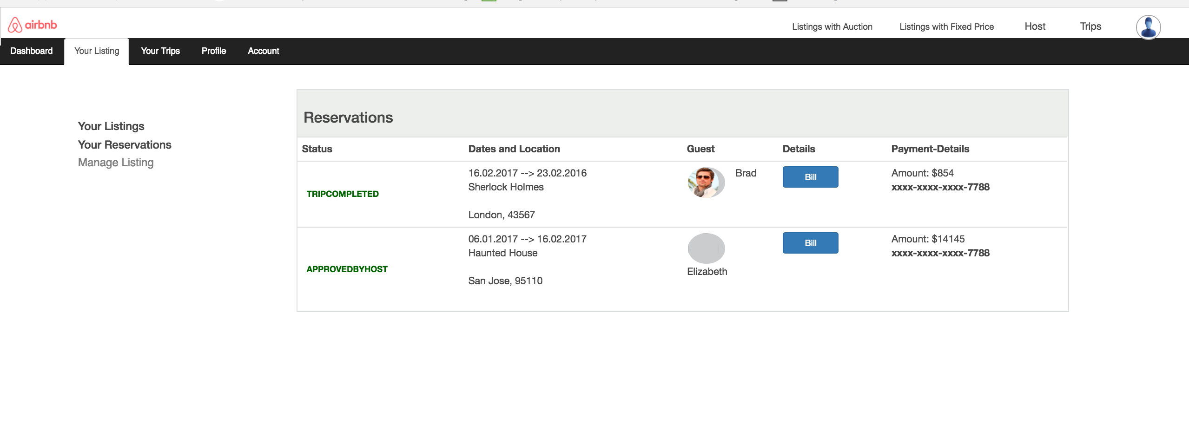

Host Dashboard:

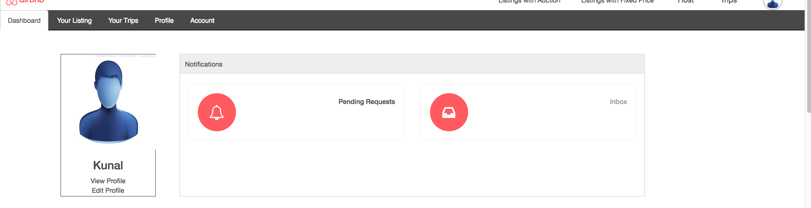

User can click on any pending requests to approve the requests:

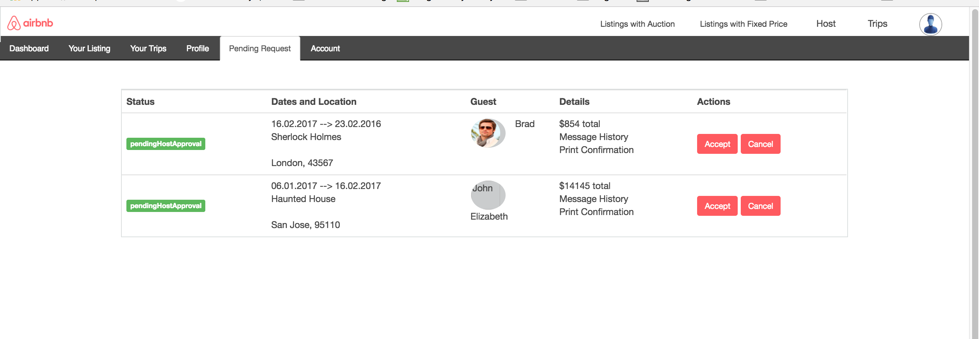

Bidding:

User can place a bid selecting listing auctions:

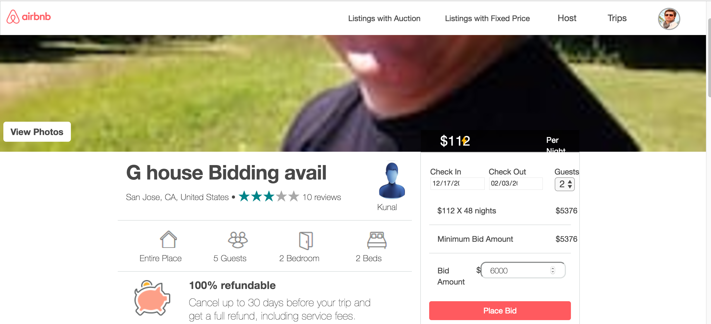

Admin Dashboard:

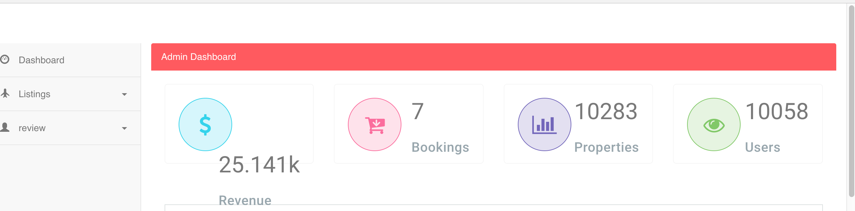

Pending Approval Listings for admin:

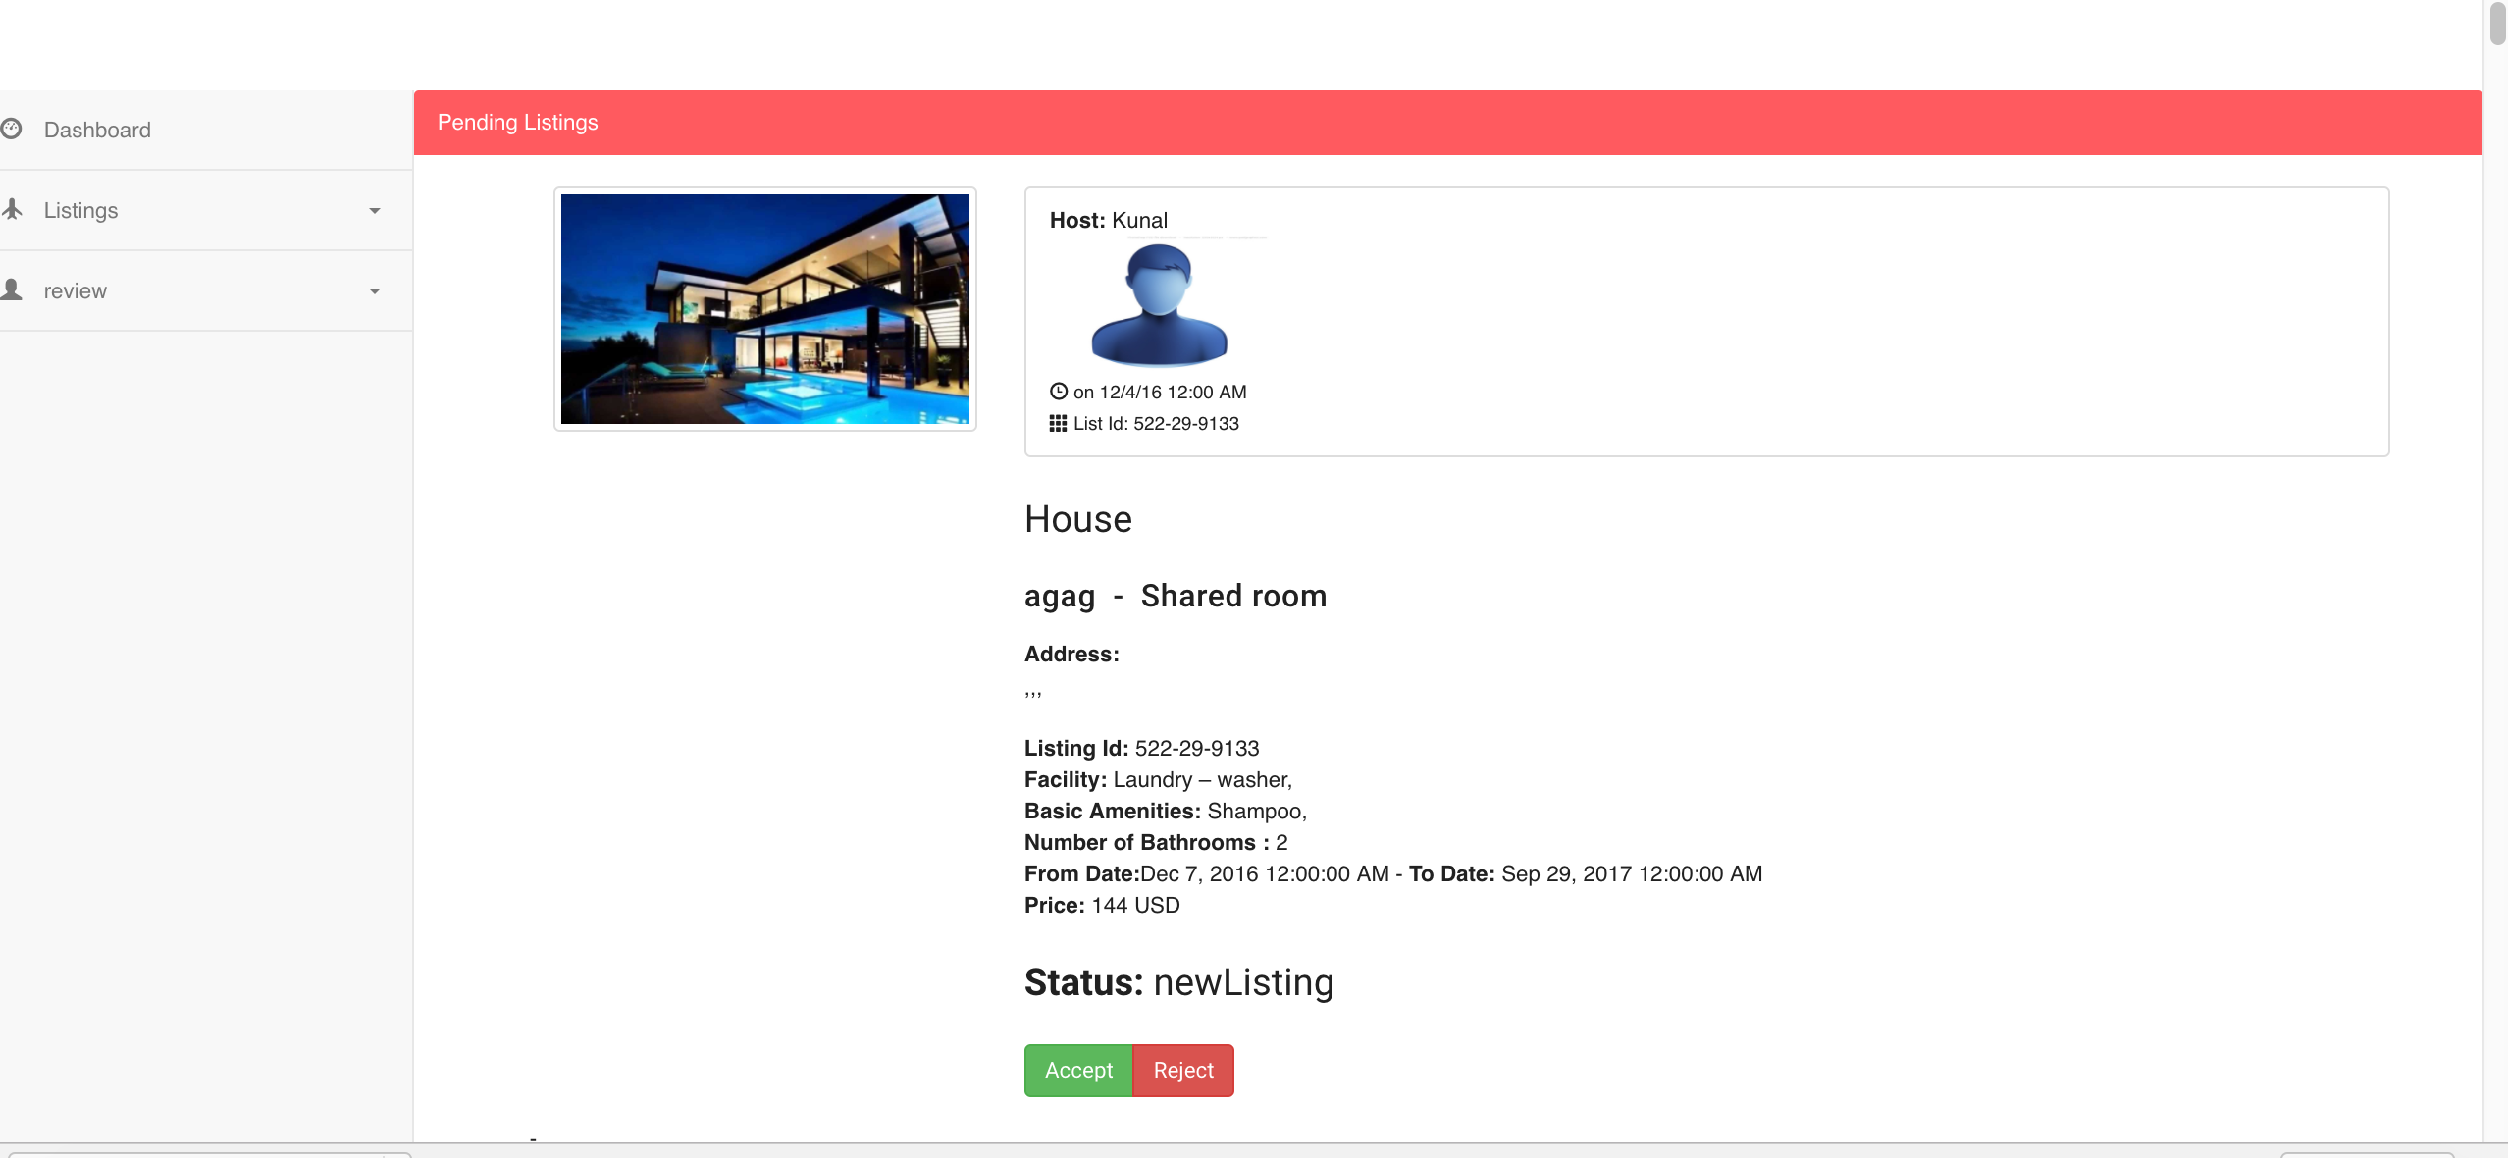

Approved Listing:

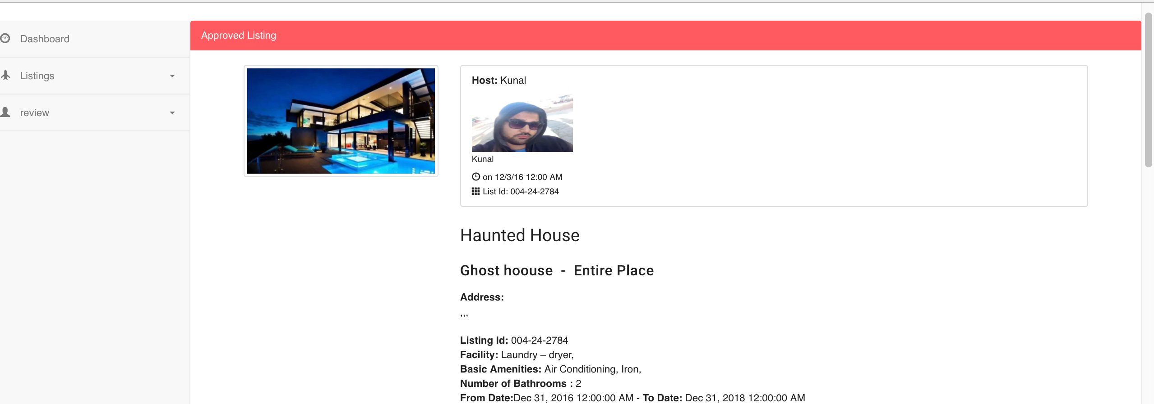

Admin can view the users:

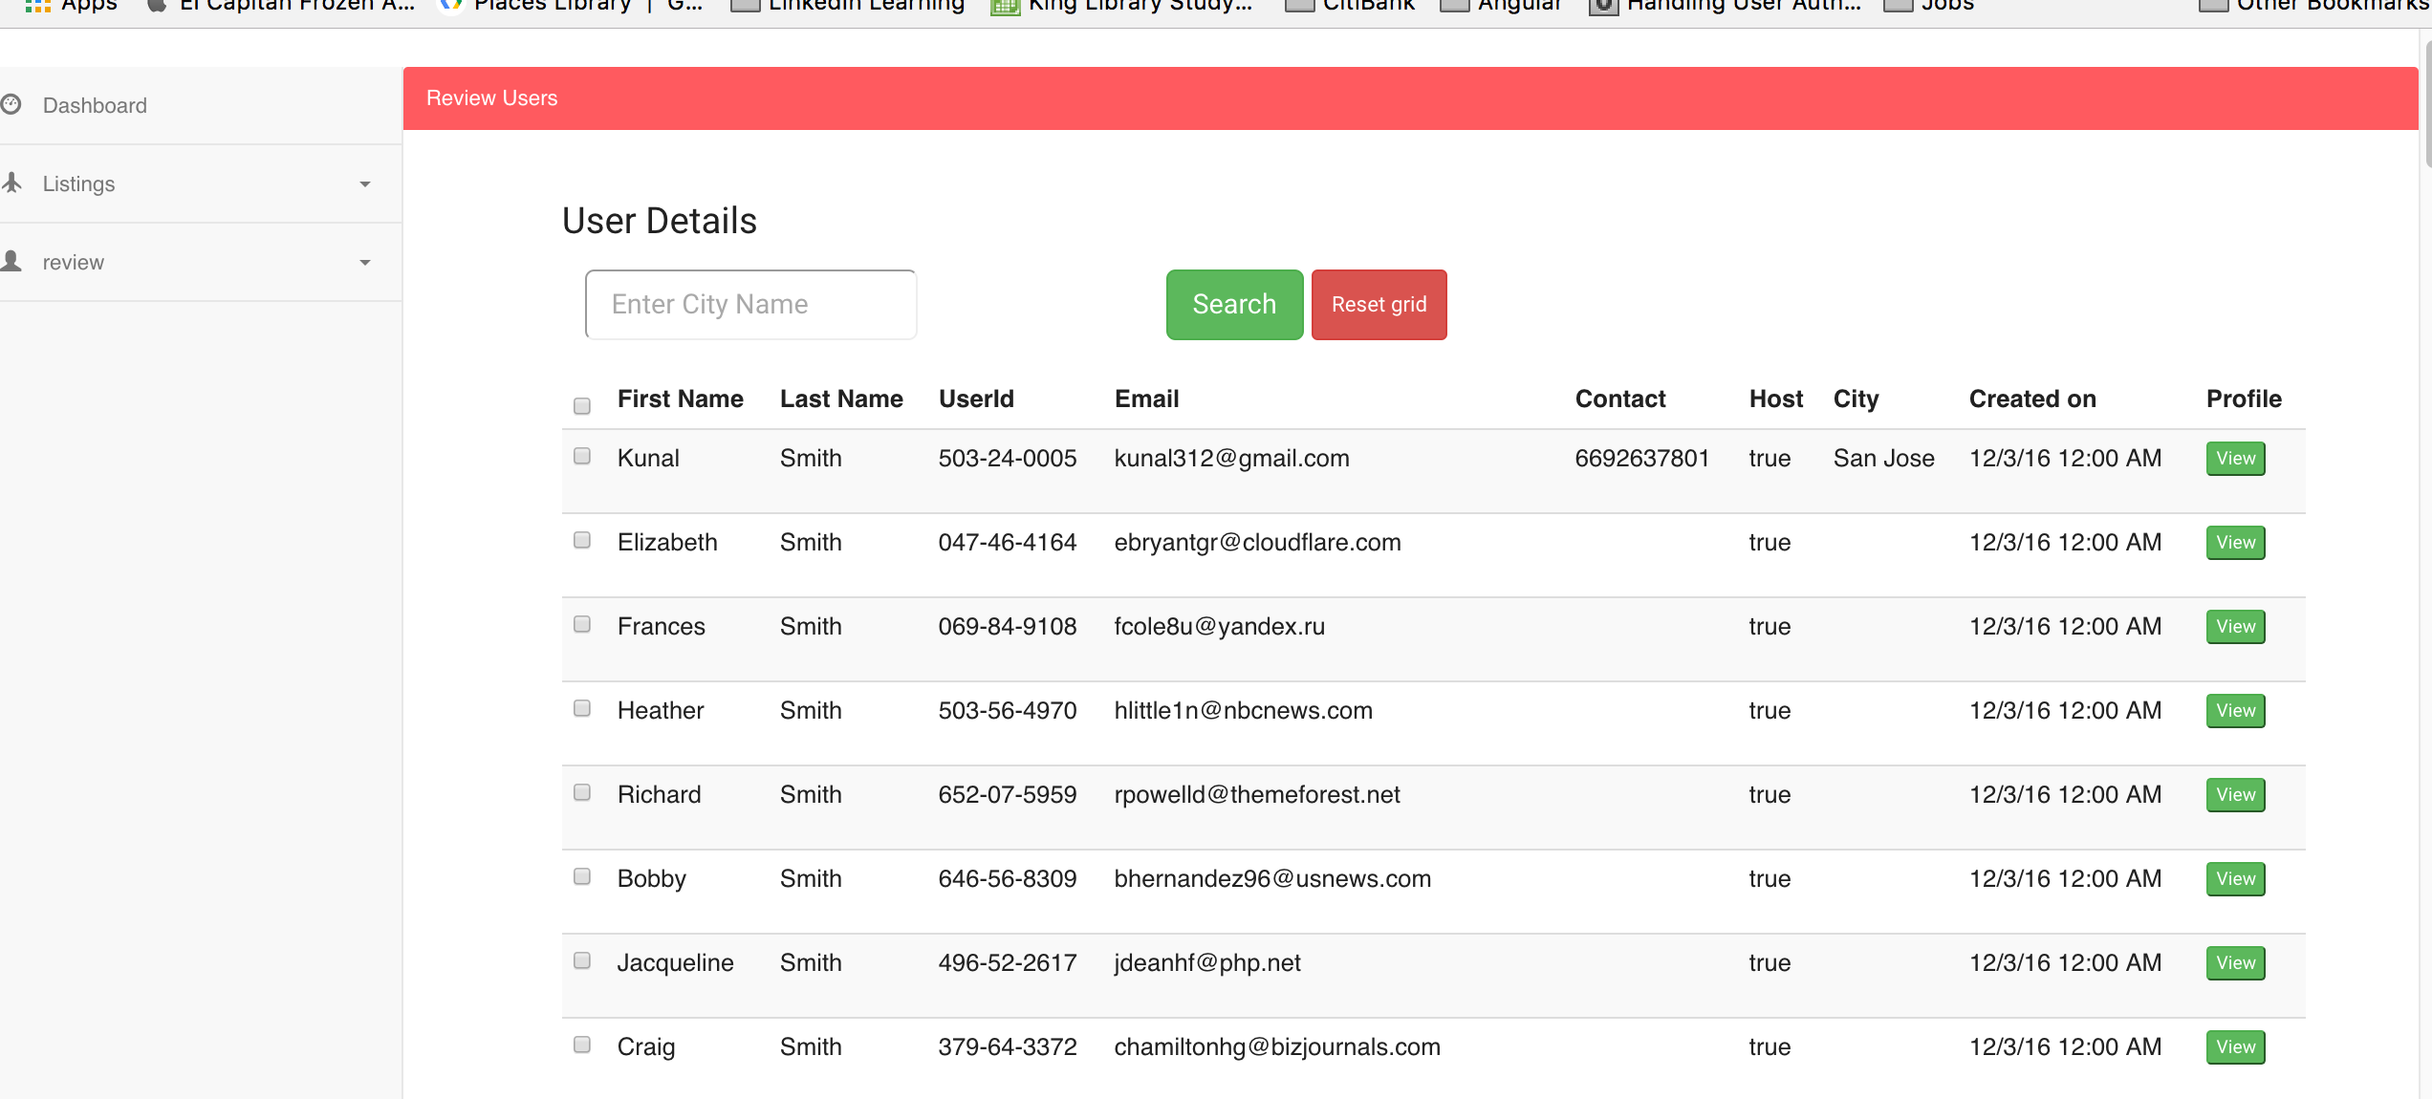

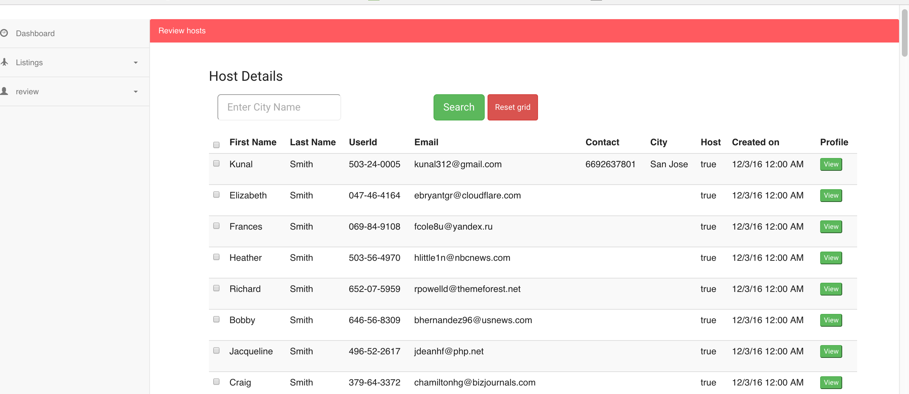

Admin can view the bills:

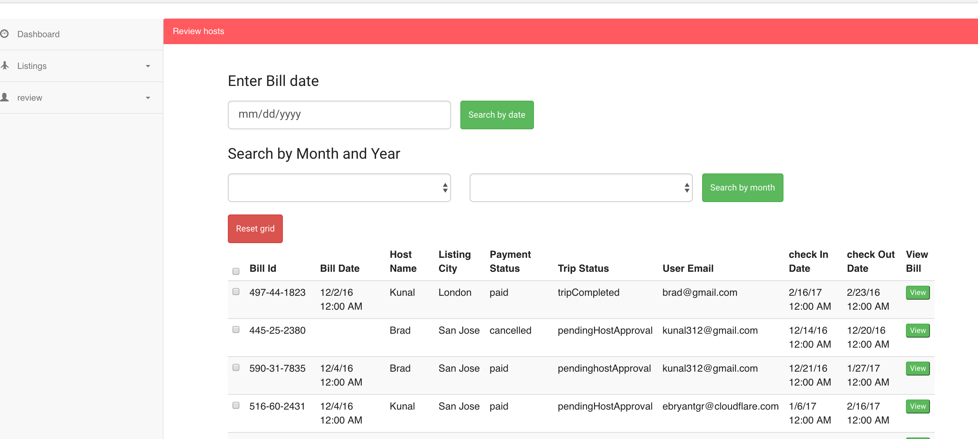

Admin Analytics graphs:

* **Admin Dashboard**

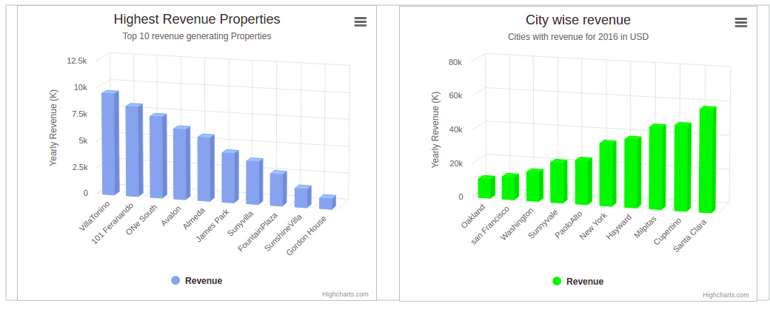

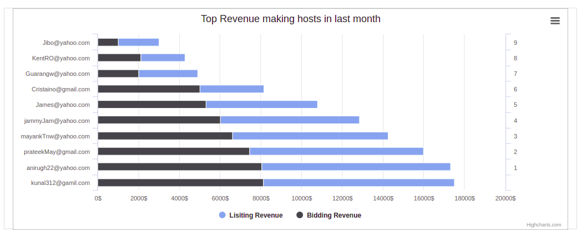

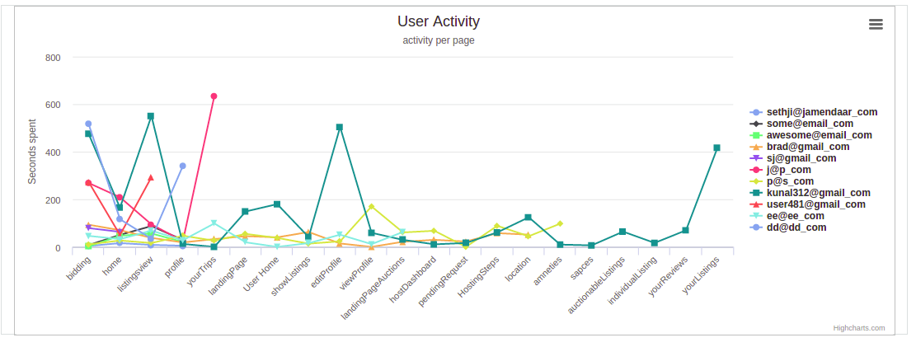

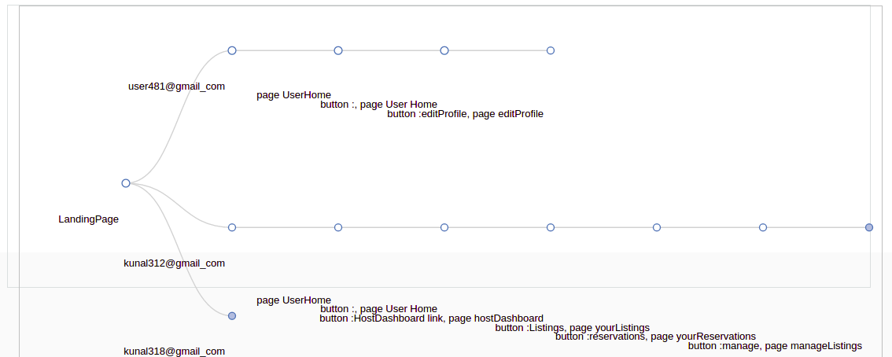

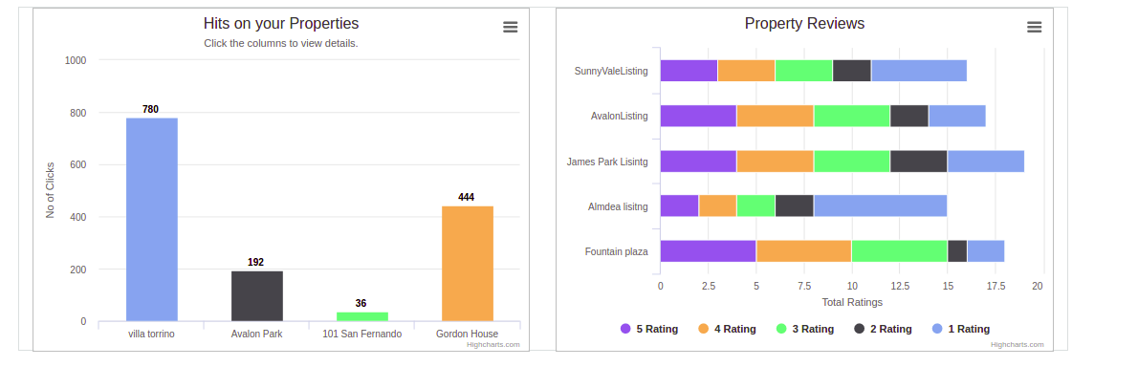

Testing:

* **Jmeter Graphs**
* ***1000 Requests -*** Base (Simple Database Connection)

Throughput / minute - 17693.896 Average - 1638 ms

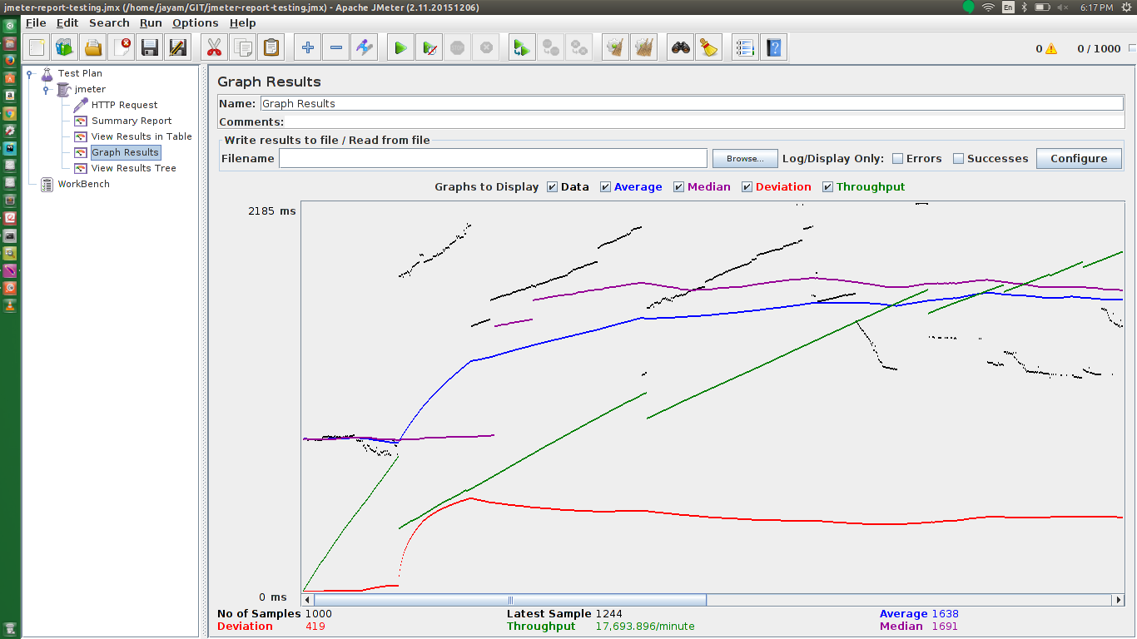

* ***3000 Requests -*** Base (Simple Database Connection)

Throughput / minute - 17436.792 Average - 3434

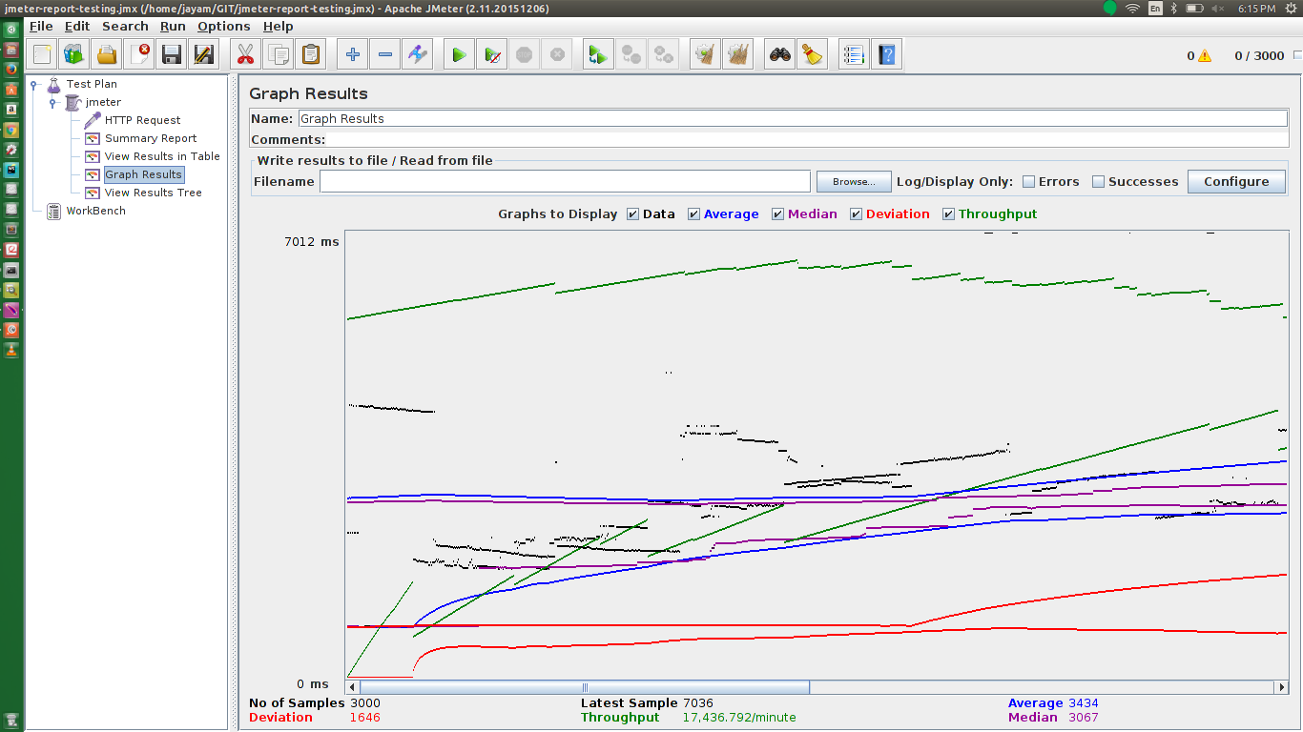

* ***5000 Requests -*** Base (Simple Database Connection)

Throughput / minute - 15182. 955 Average - 3958

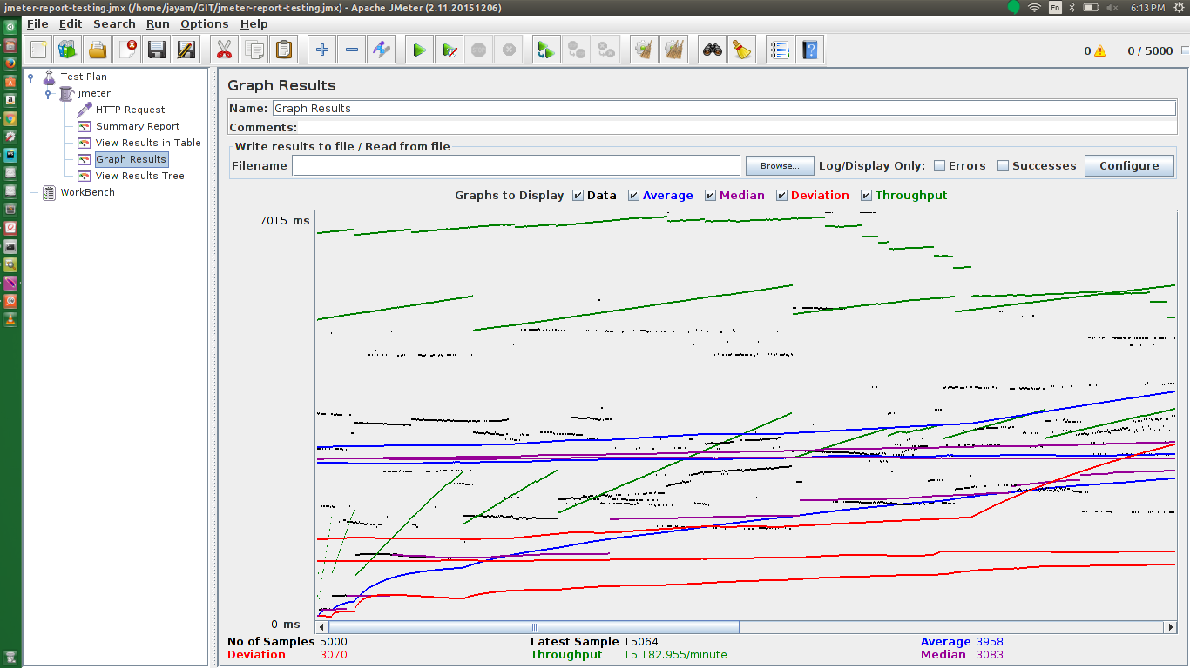

* ***10000 Requests -*** Base (Simple Database Connection)

Throughput / minute - 14771.412 Average - 6412

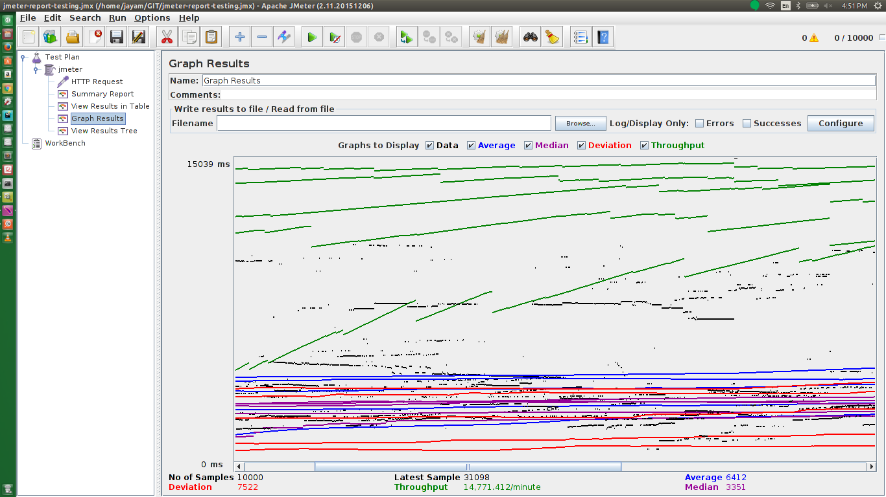

* ***1000 Requests -*** Base + Connection Pooling

Throughput / minute - 22970.904 Average – 828

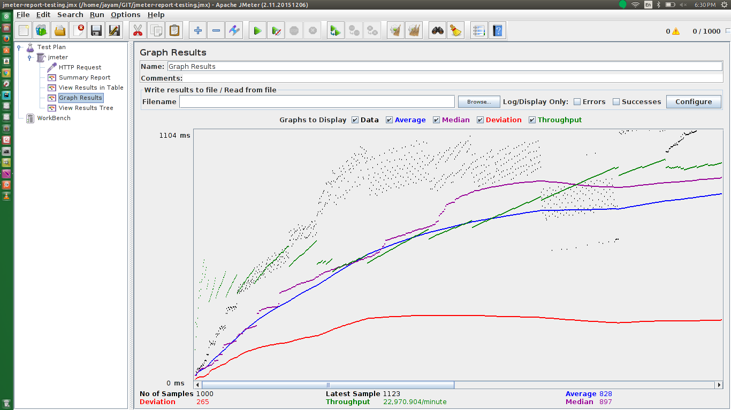

* ***3000 Requests -*** Base + Connection Pooling

Throughput / minute - 17804.154 Average – 2764

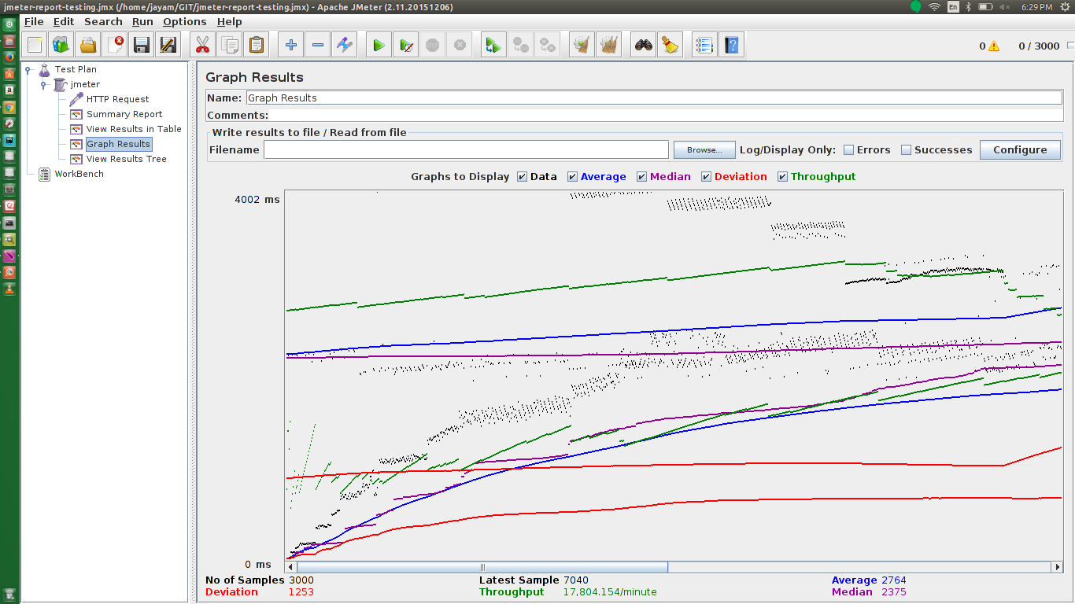

* ***5000 Requests -*** Base + Connection Pooling

Throughput / minute - 16606.698 Average – 5150

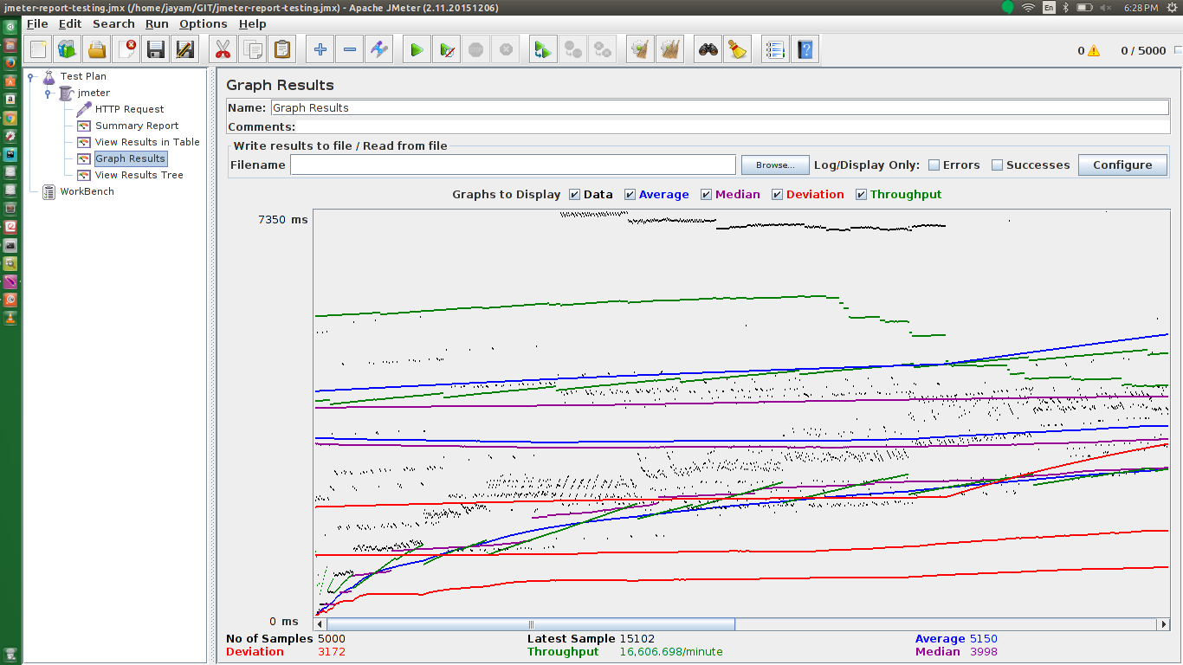

* ***10000 Requests -*** Base + Connection Pooling

Throughput / minute - 16178.176 Average – 6736

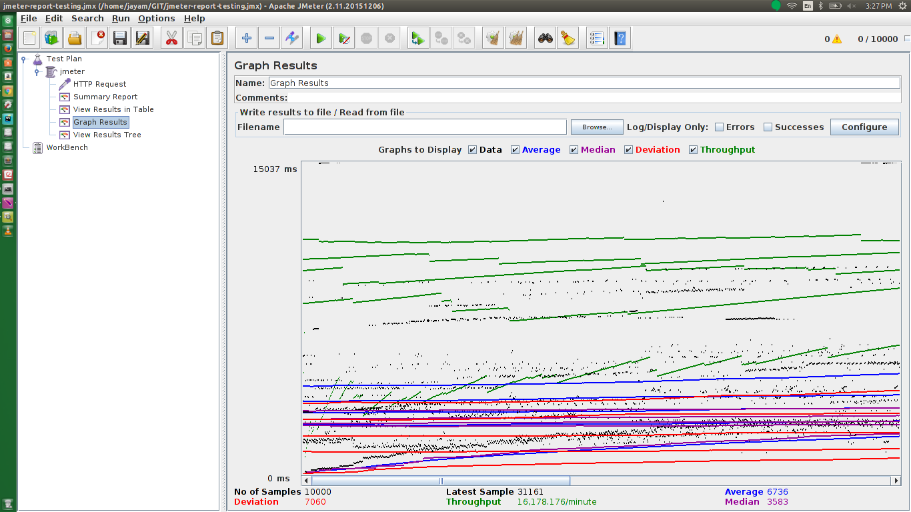

* ***1000 Requests -*** Base + Connection Pooling + RabbitMQ

Throughput / minute - 24135.157 Average – 471

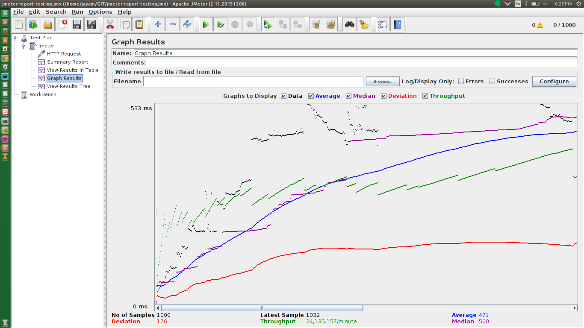

* ***3000 Requests -*** Base + Connection Pooling + RabbitMQ

Throughput / minute - 19942.389 Average – 1821

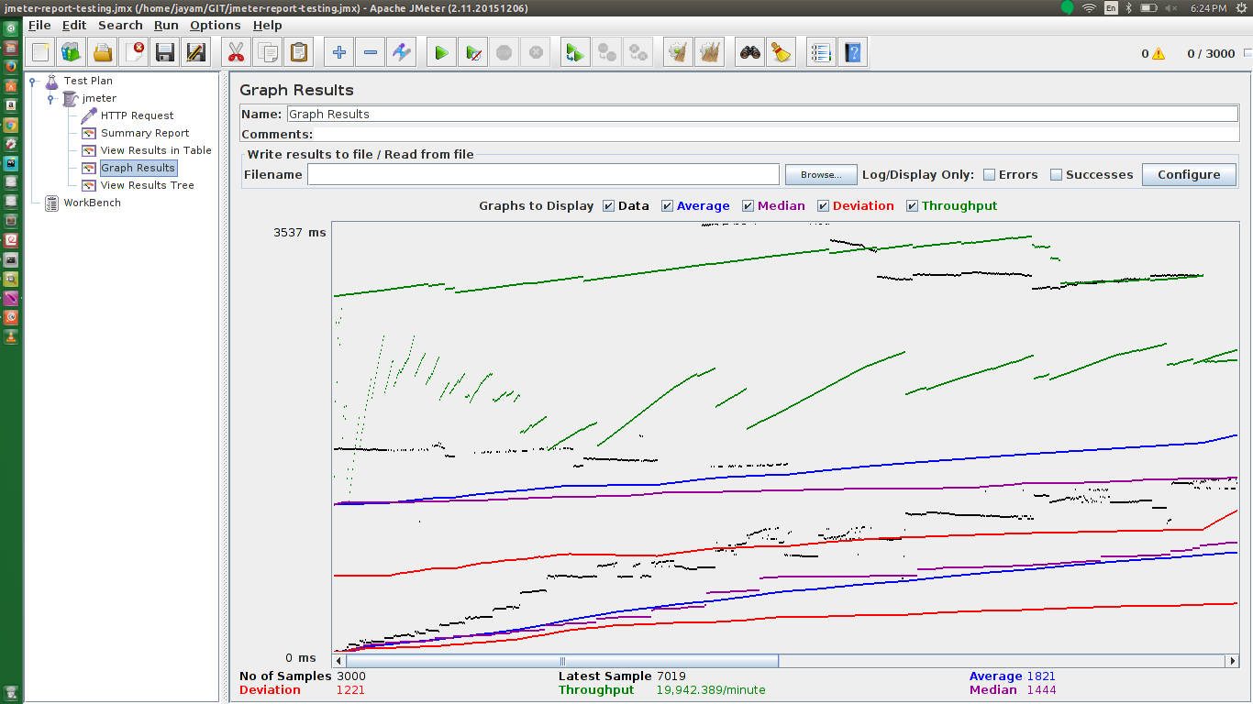

* ***5000 Requests -*** Base + Connection Pooling + RabbitMQ

Throughput / minute - 17568.517 Average – 3311

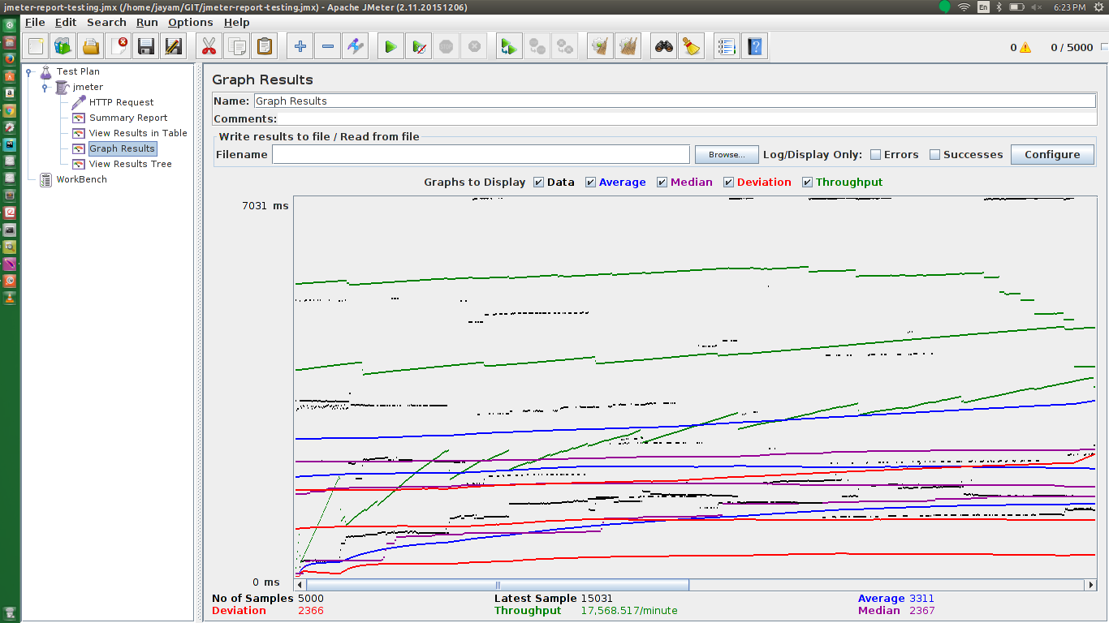

* ***10000 Requests -*** Base + Connection Pooling + RabbitMQ

Throughput / minute - 15492.267 Average – 4876

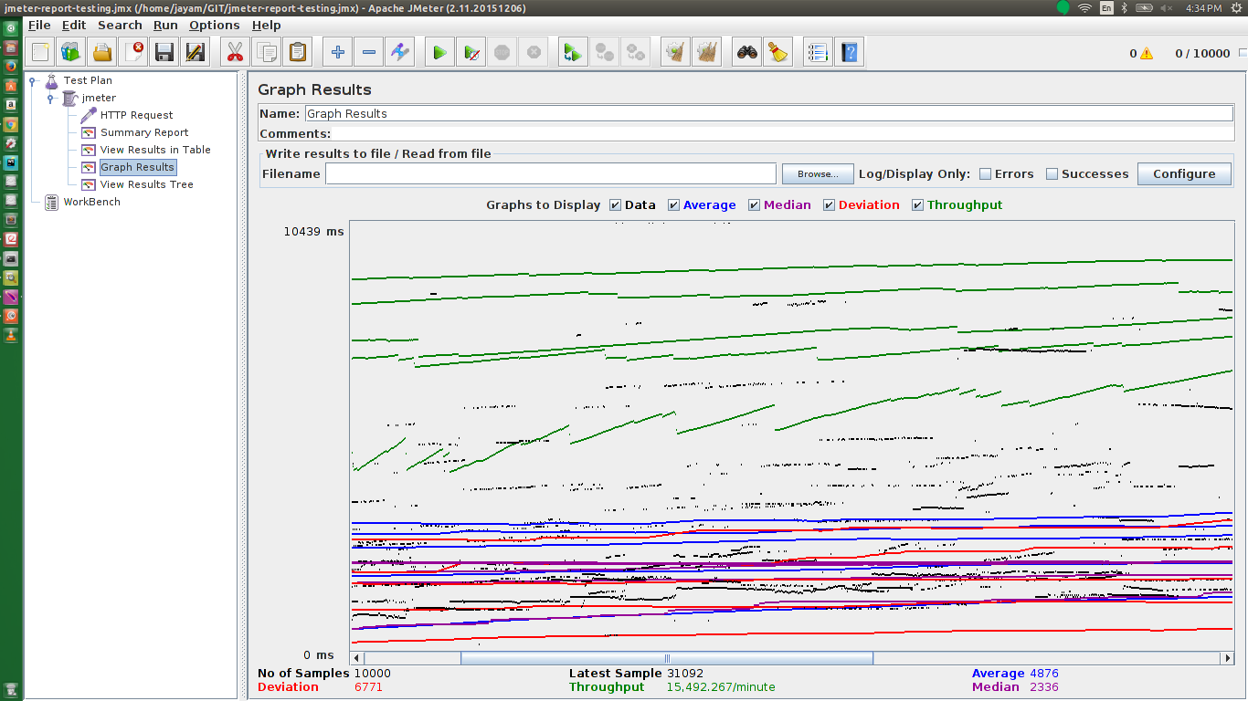

* ***1000 Requests -*** Base + Connection Pooling + RabbitMQ + Redis

Throughput / minute - 35108.25 Average – 160

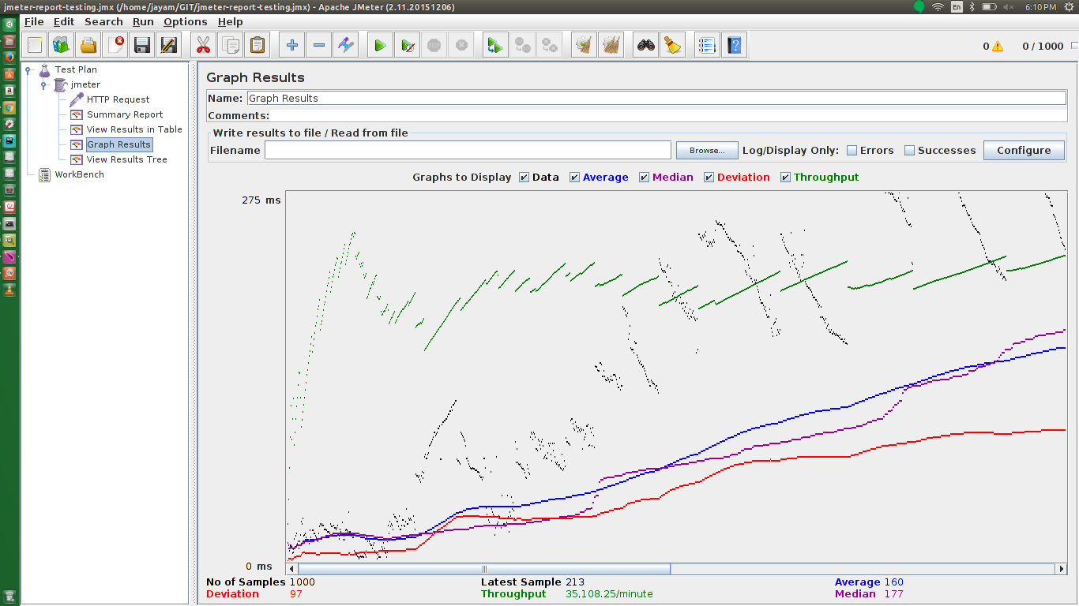

* ***3000 Requests -*** Base + Connection Pooling + RabbitMQ + Redis

Throughput / minute - 21474.588 Average – 710

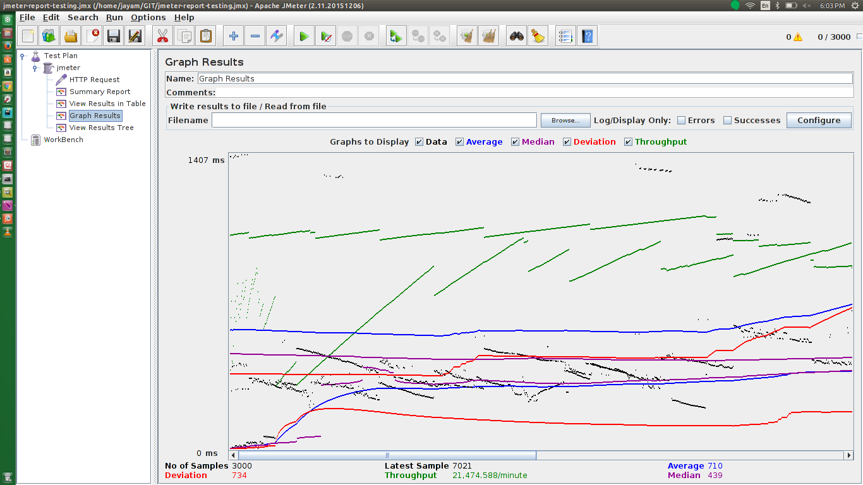

* ***5000 Requests -*** Base + Connection Pooling + RabbitMQ + Redis

Throughput / minute - 18517.375 Average – 1874

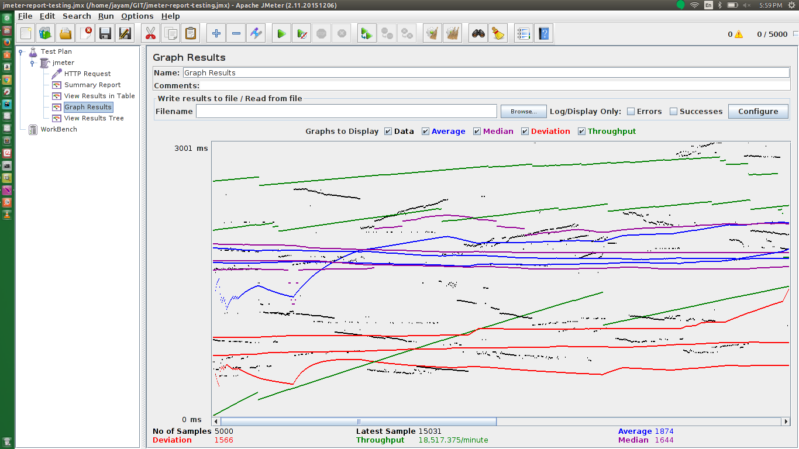

* ***10000 Requests -*** Base + Connection Pooling + RabbitMQ + Redis

Throughput / minute - 35688.794 Average – 817

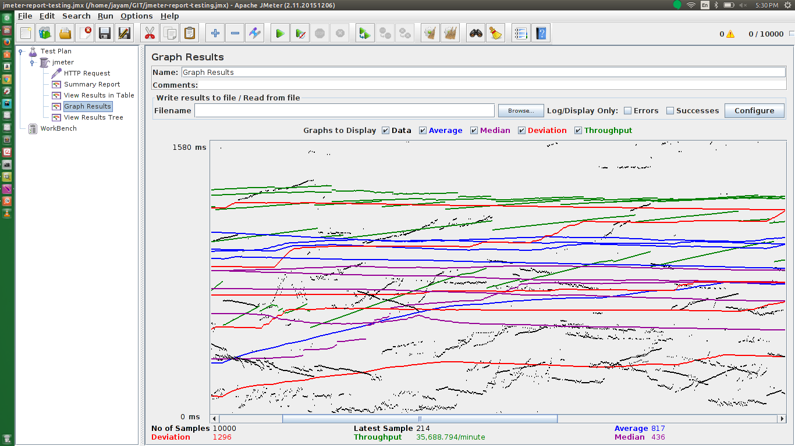

* **Comparison of Throughput gain after adding features**

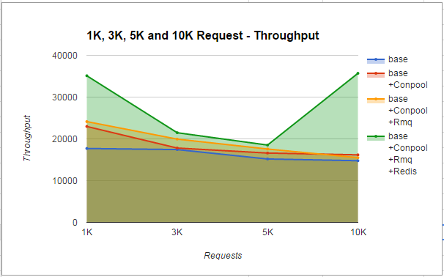

As we can observe from the above graph, we have improved our applications overall throughput after adding performance gaining features like database connection pooling, RaabitMQ and Redis. Among these we have found to gain maximum throughput when using RabbitMQ and Redis in conjunction. RabbitMQ gives us ability to handle huge number of requests by pushing them in to asynchronous message queues, this gives us ability to absorb huge traffic of incoming requests and still respond to each without losing any request. On top of this we have used Redis, Redis gives us this unique ability to cache data in memory. Redis is an in memory database, this makes it an ideal candidate to cache resources effectively. This is a great advantage for huge traffic and load bearing servers. With these unique abilities technologies working in harmony with each other, we have been able to achieve this performance.

**Comparison of Average time after adding features**

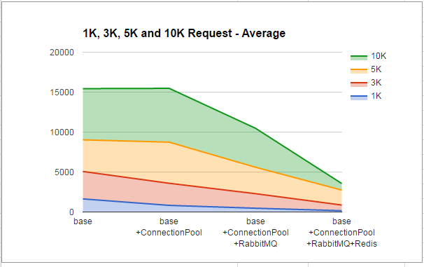

* **Mocha Testing**

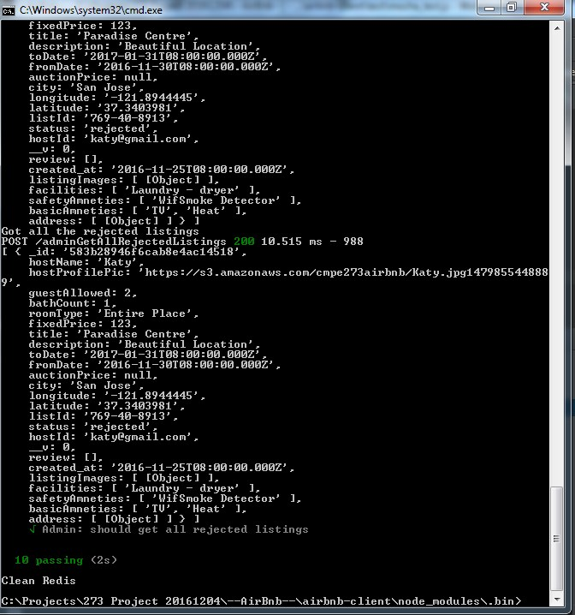

**Dynamic Pricing:**

**Dynamic Pricing - Dynamic pricing will be applied using four parameters.**

**1: Property Clicks**

**2: User Reviews**

**3: User Rating**

**4: Property Rating**

**5: Festival Days Special Offer**

**Our first most prominent parameter for doing dynamic pricing for a property will be the property popularity it self, the property that has more number of clicks will be considered will have more impact for dynamic pricing. On top of that we will consider the user reviews for the property, the property that is more user favourable will be more costlier as compared to rest. After that we will consider user rating of the user having listing, if the user has more rating than his property will have more affinity for costlier price & vice versa. After that we will consider the property rating, the property having more ratings will be costlier & vice versa. After all these parameters we will also consider the Festival days, these will be the final dynamic part. We will apply this model for dynamic pricing.**

* **Ionic Screenshots**

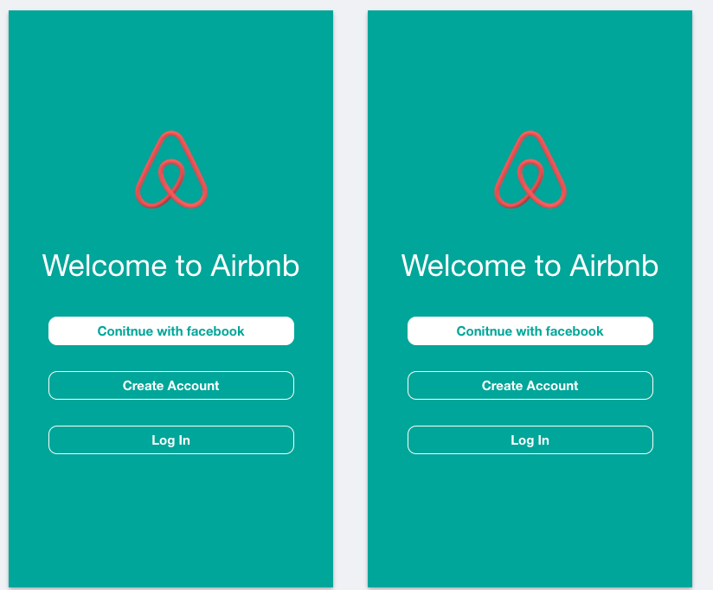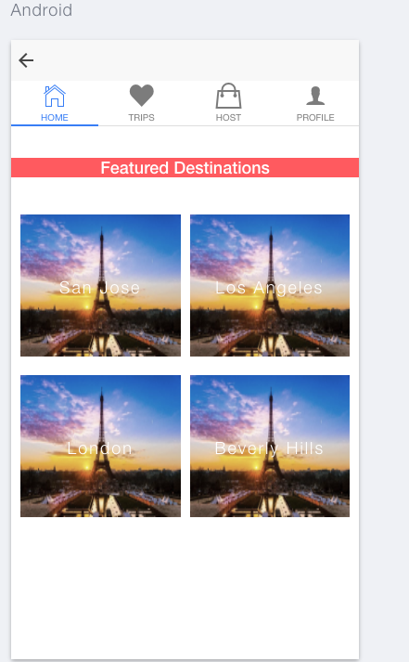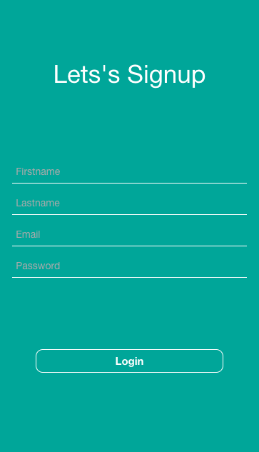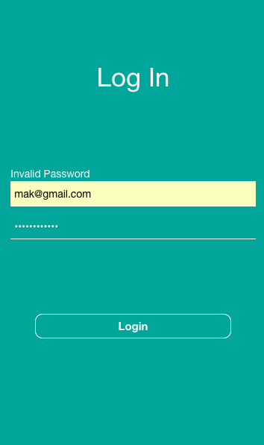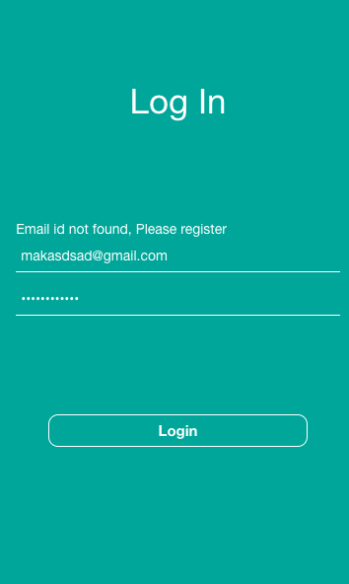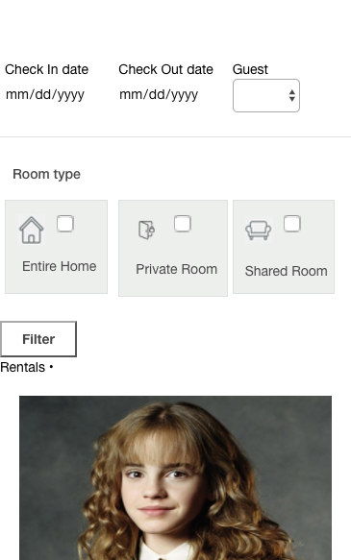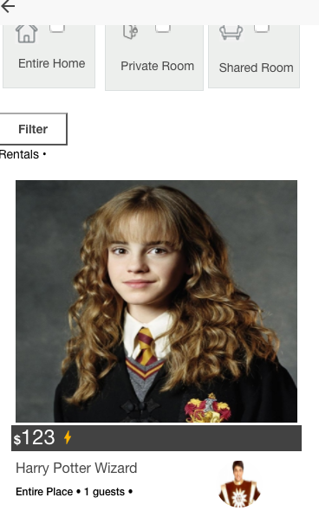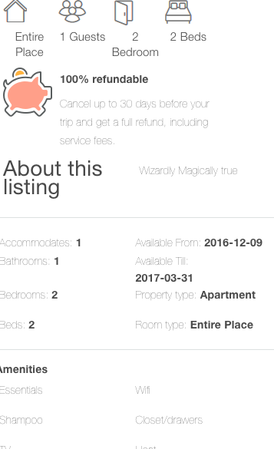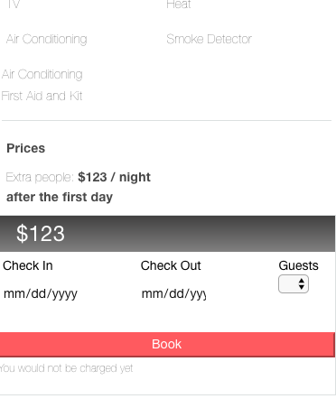

**Code Listing:**

**Database:**

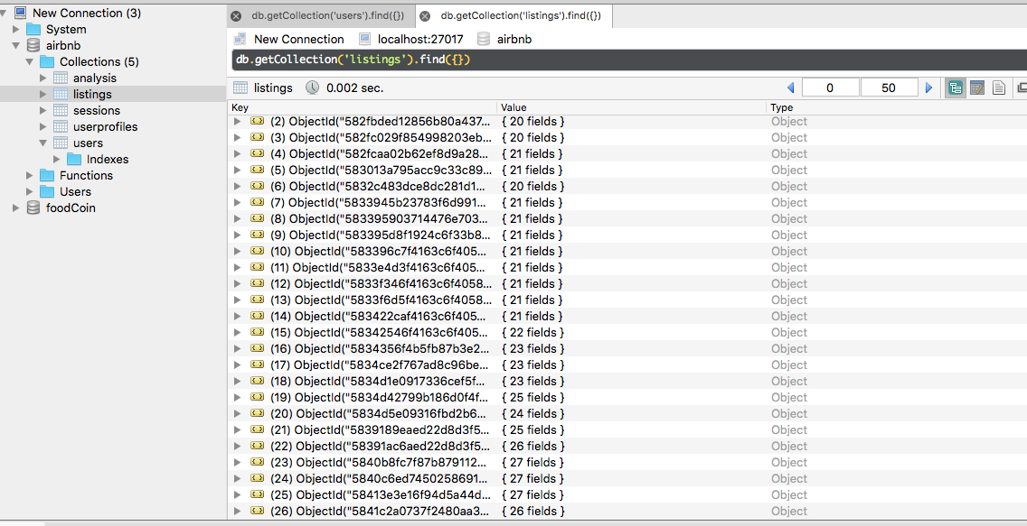

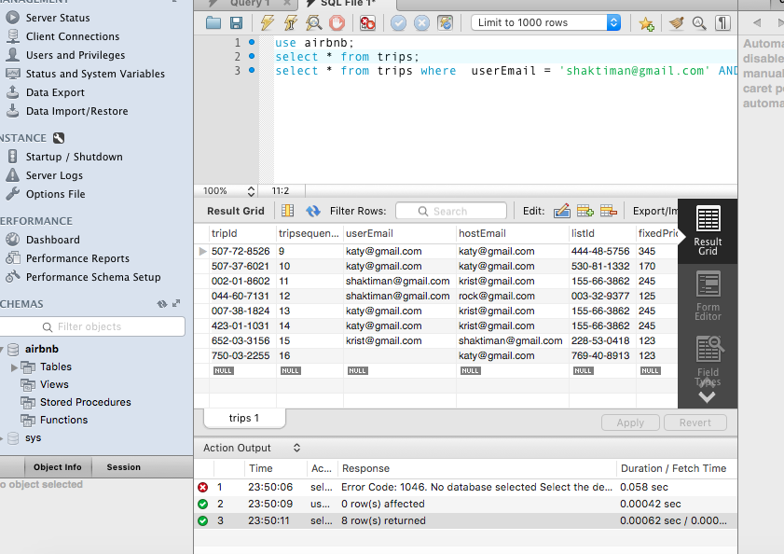

Code Listing: Server Side:

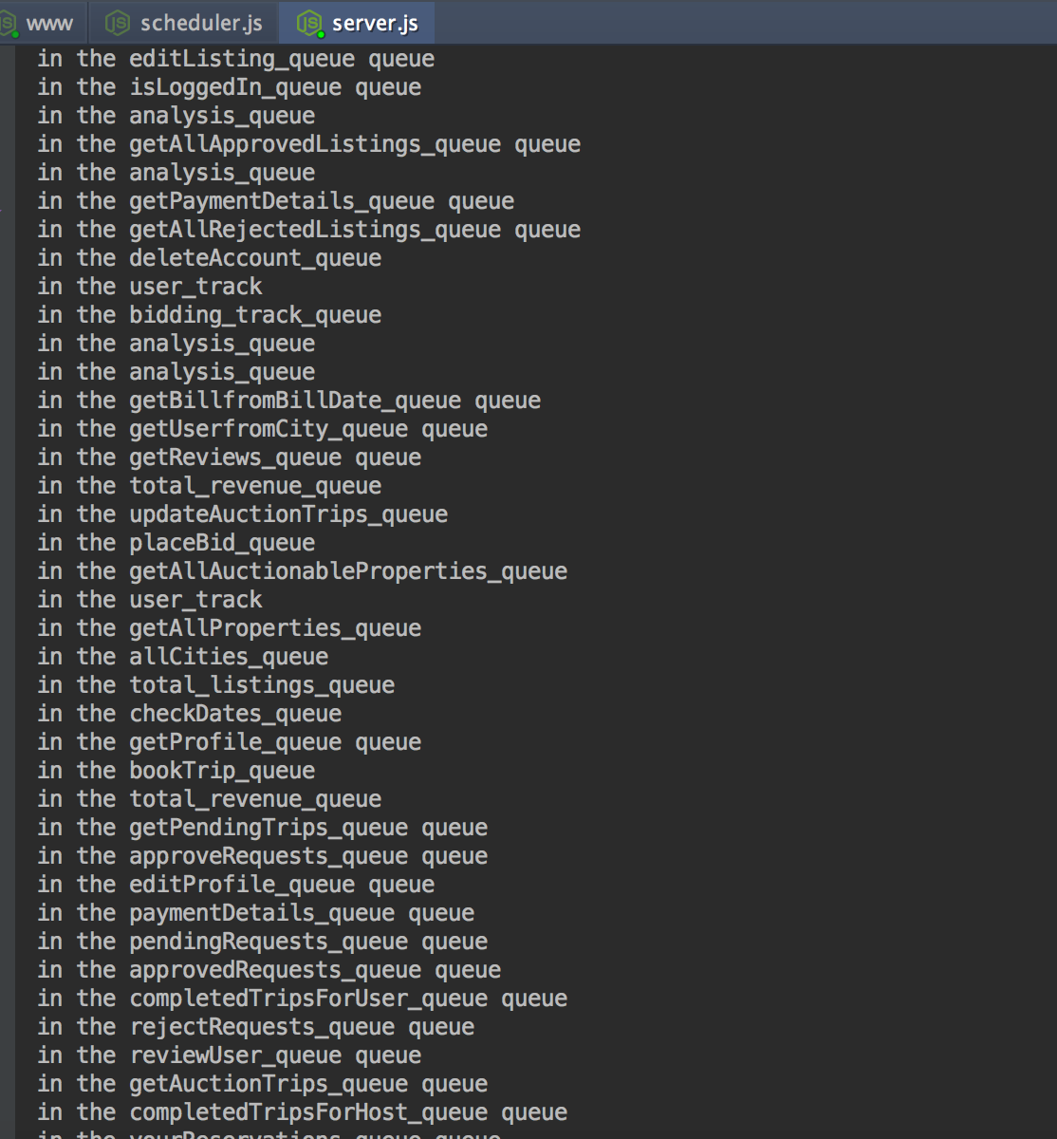

Express Session:

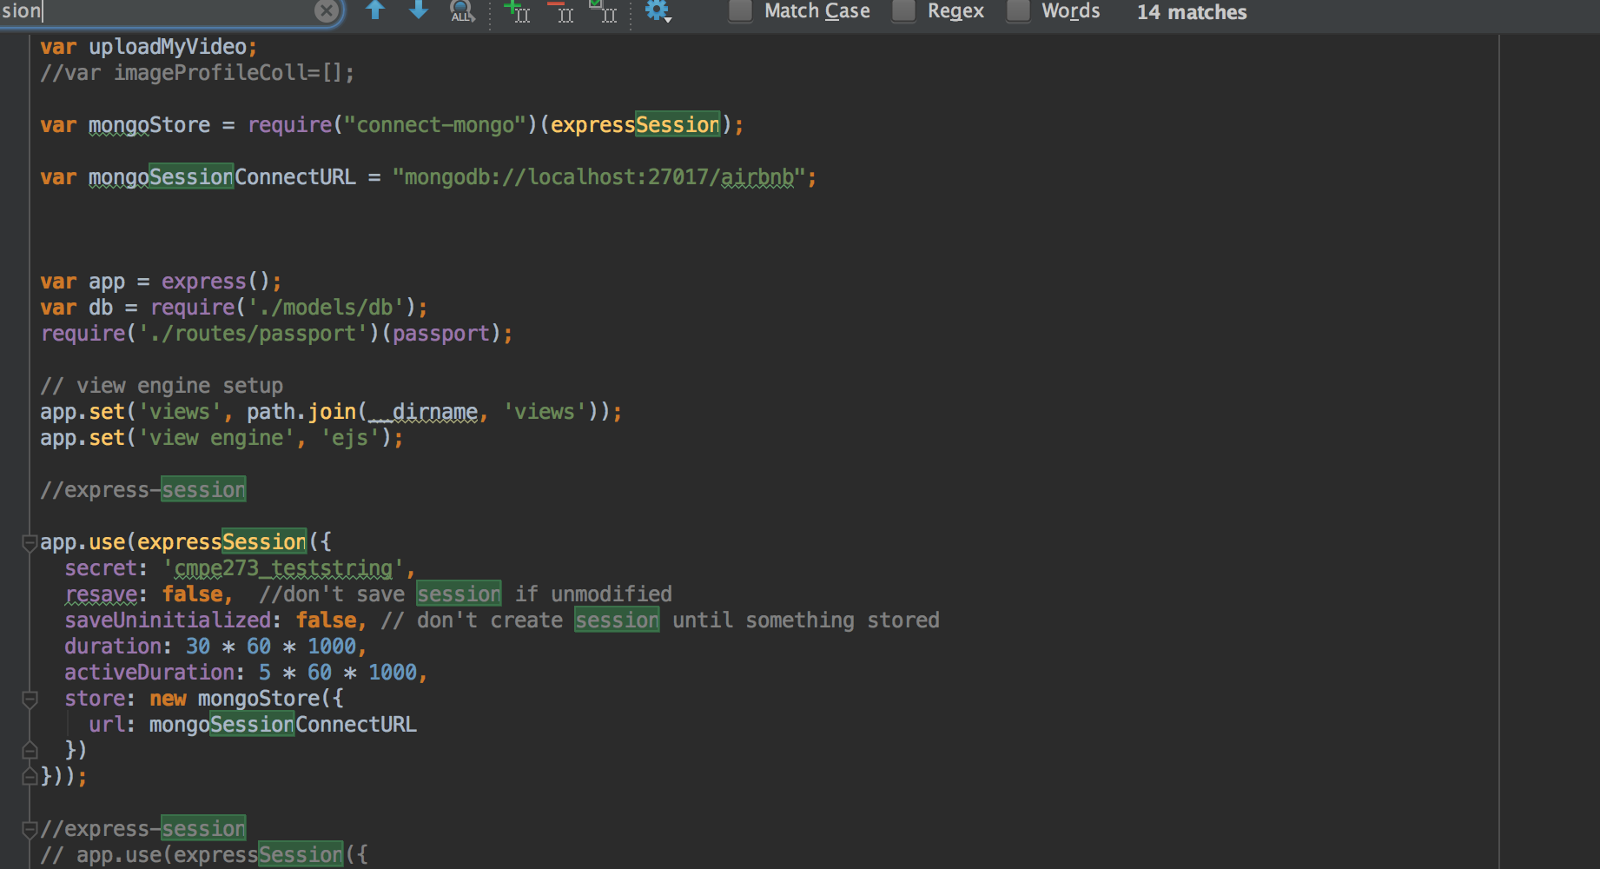

Code Listing for client side:

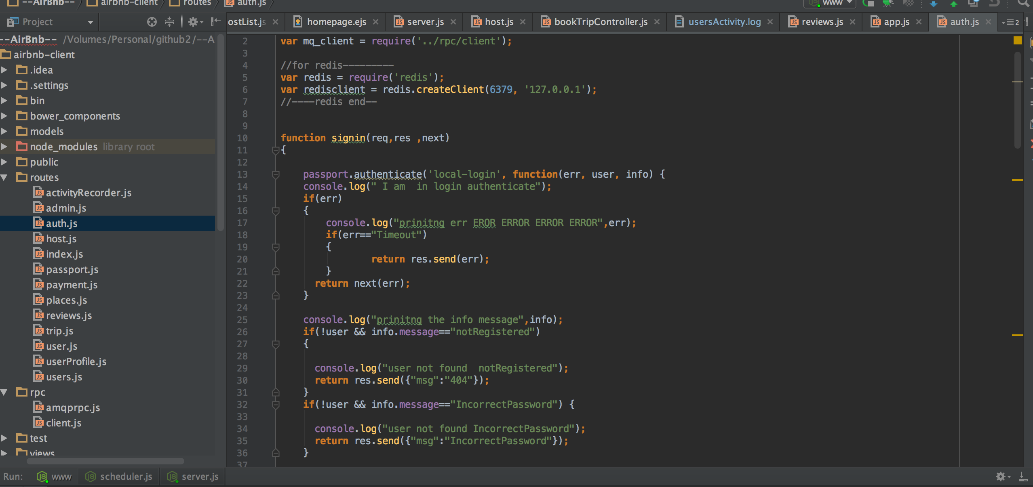

Database access classes:

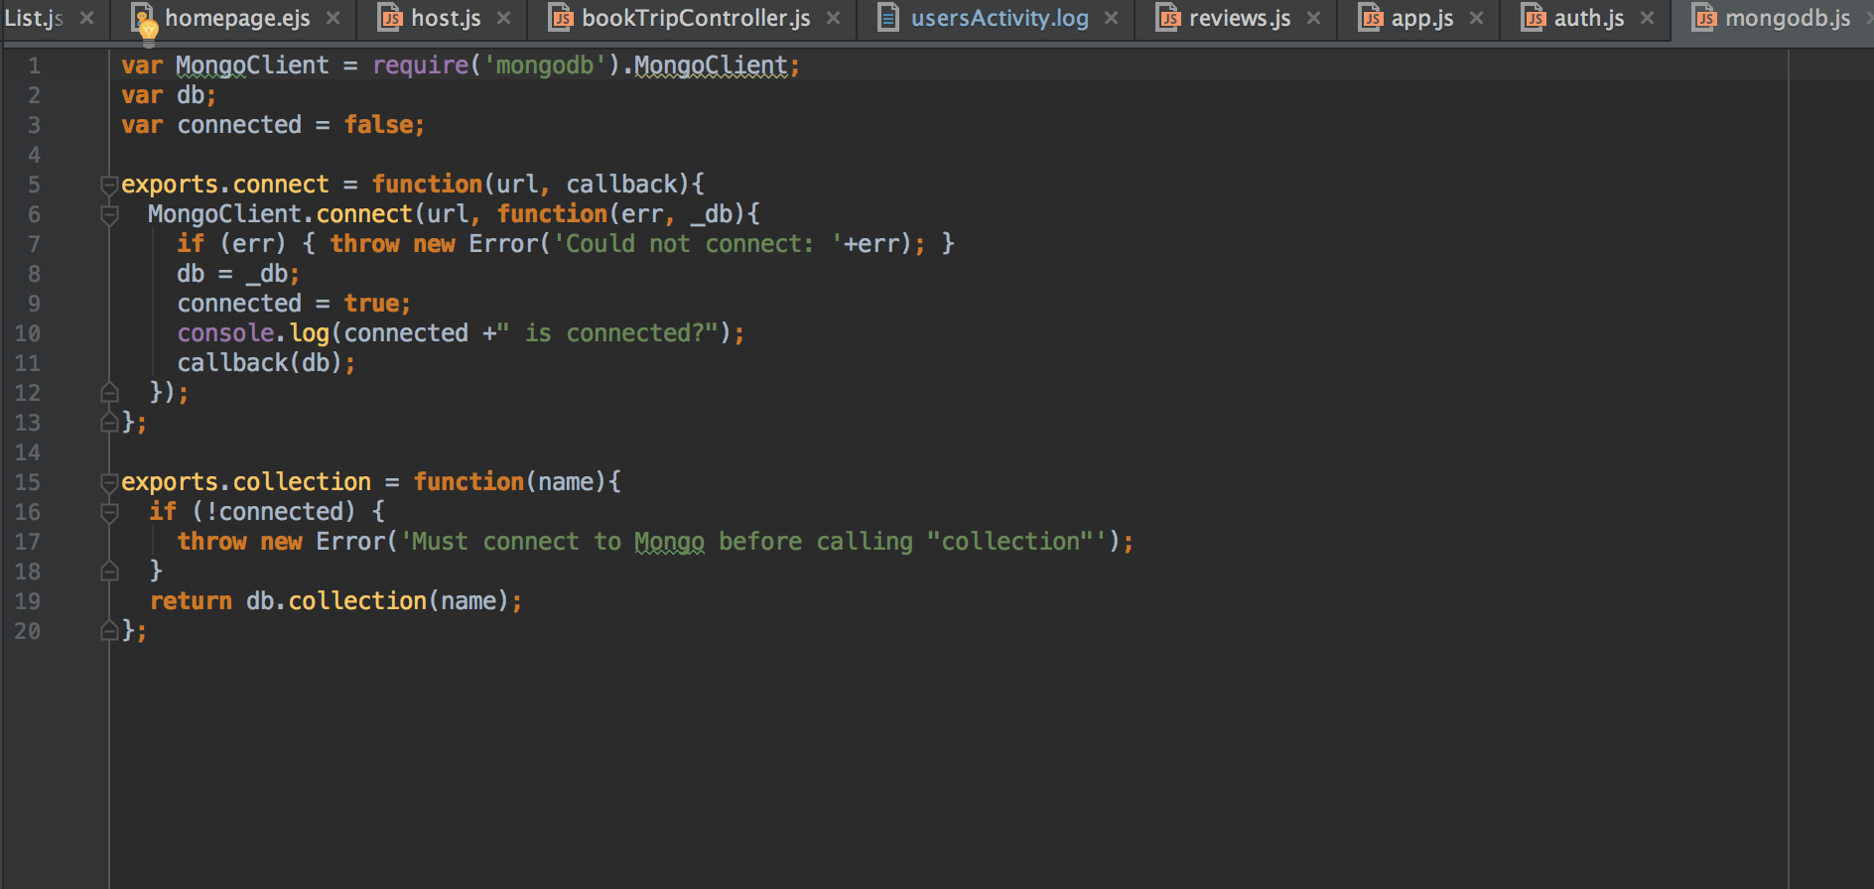

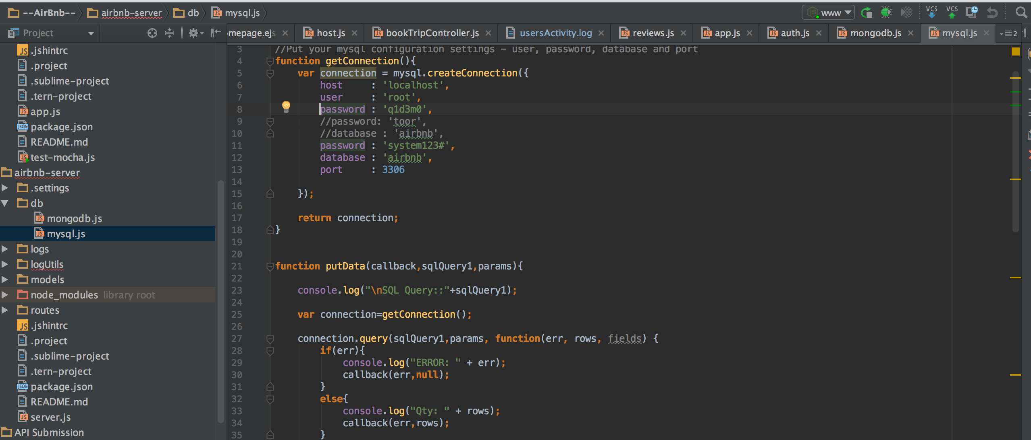

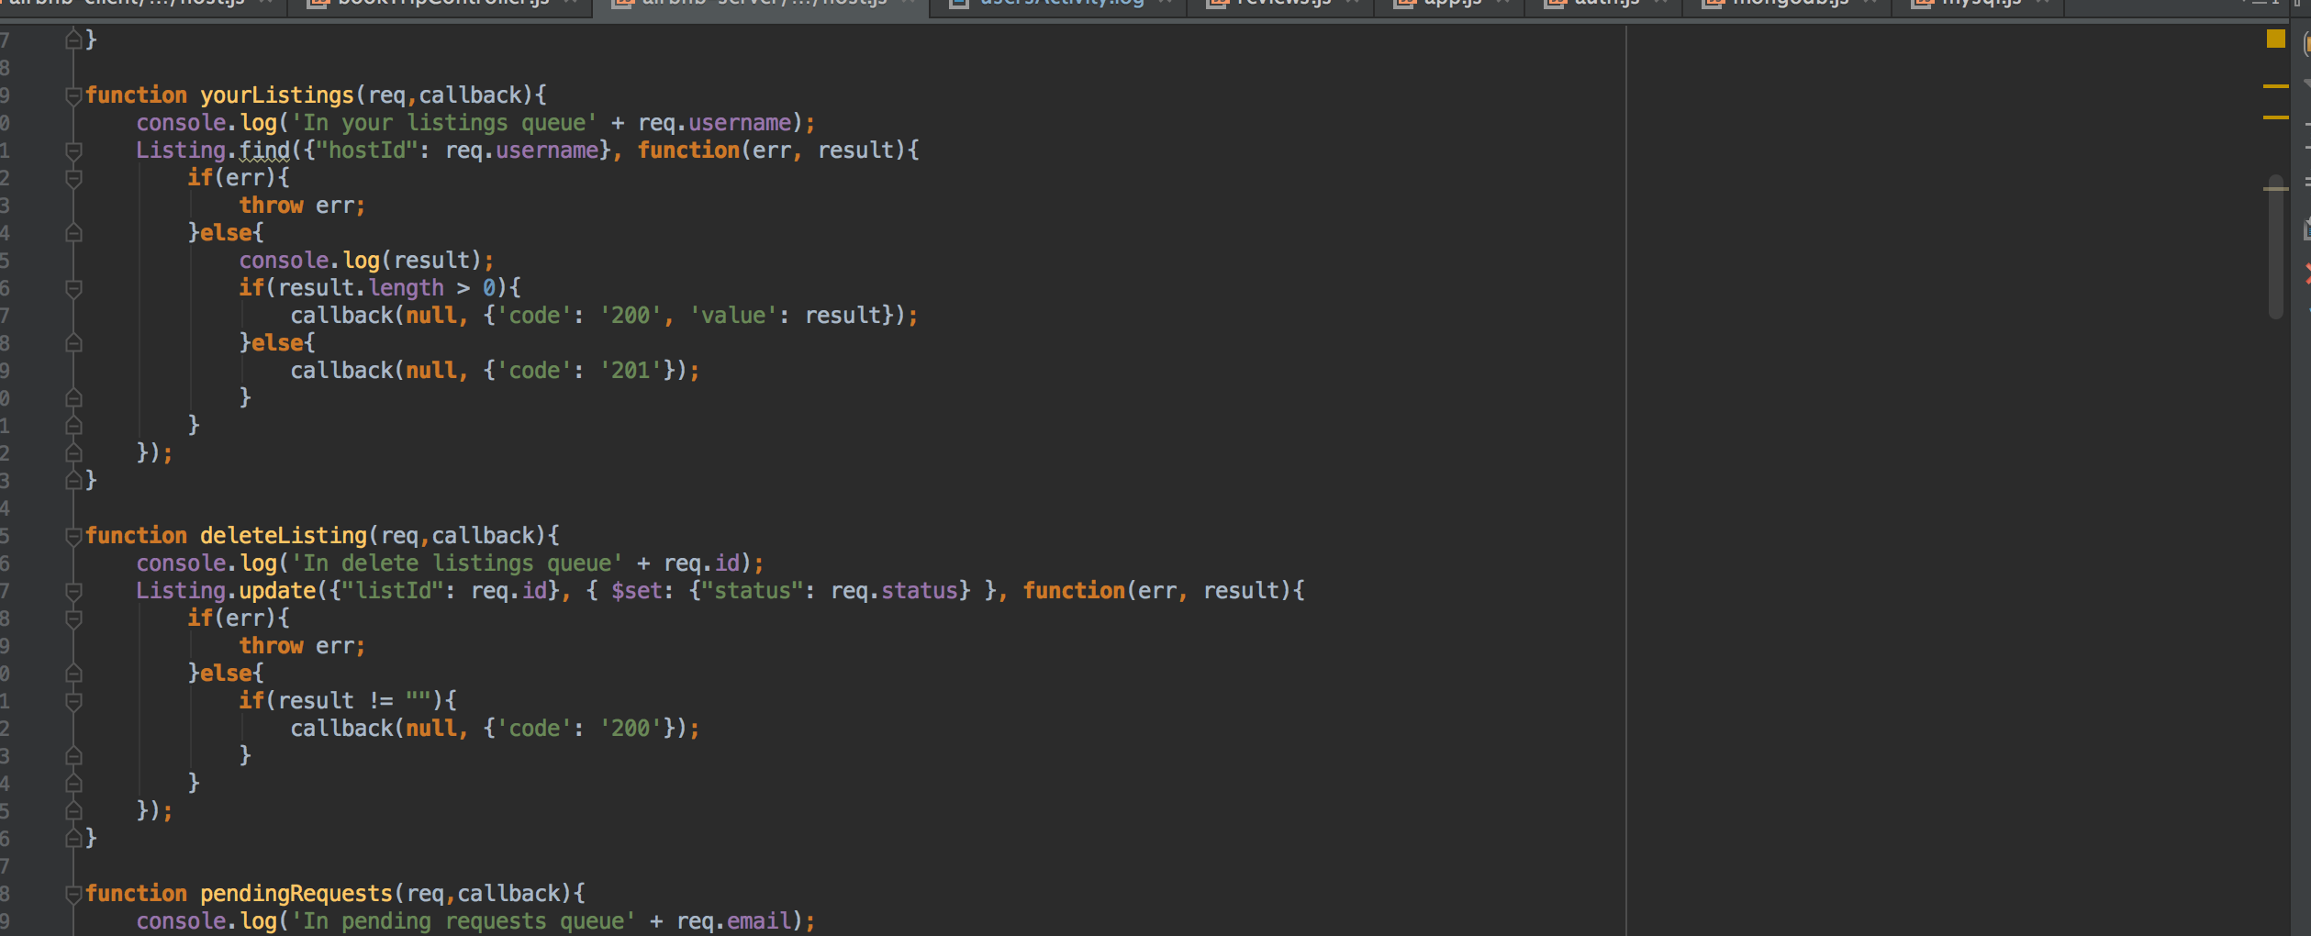

**Lessons Learned**

The System has taught us in great detail on how the Enterprise solutions should be architectured in order to create a large scalable and maintainable web application. We have created RESTful stateless service as a uniform communication API for requesting & sending resource. At the database level connection polling helped us in gaining better throughput by maintaining already created connections. We have also learnt that AMQP protocol used in our application via RabbitMQ can be used as a asynchronous message passing mechanism. This gives us a great deal of scalability. On top of that applied with Redis, will make a web application even quicker by caching and sharing the resources from in memory cache.